**Lesson Plan/Format**

NAME Dina Hoeynck COURSE INSTRUCTOR

**I. PROJECT TITLE:**  Textured Clay Self-Portraits

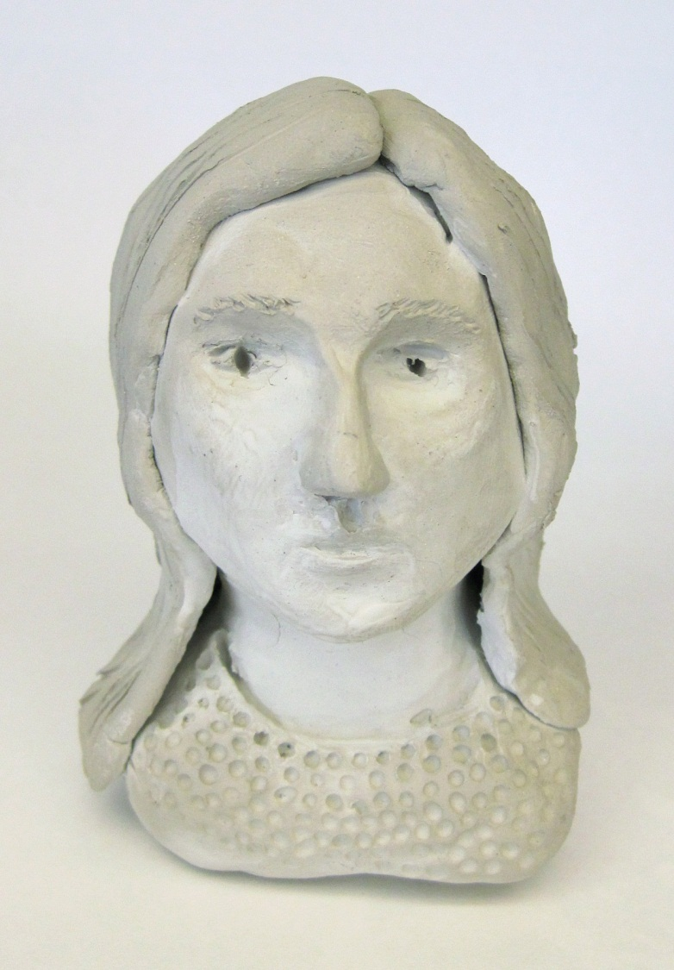 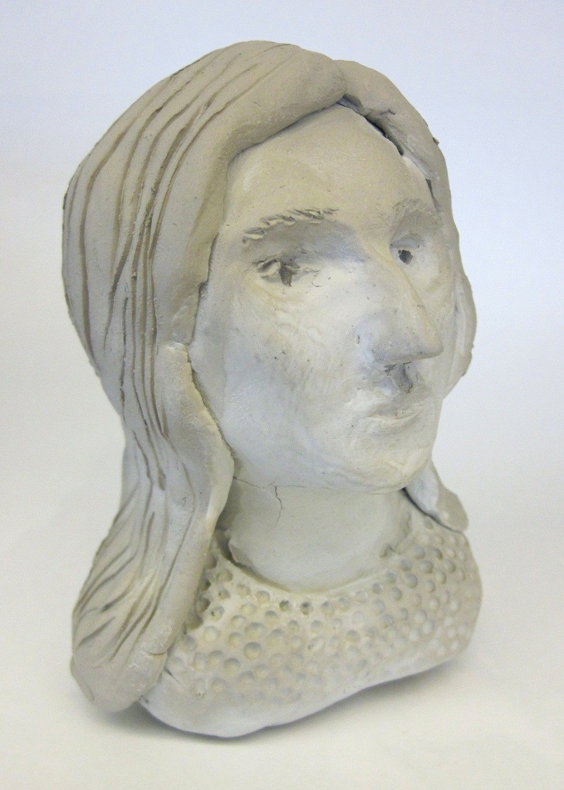

A. Where Art Classroom

B. Grade/Student Level 5th Grade

C. Class/Date/Times Two 50 minute periods

D. Room Description

**II. CURRICULUM CONTENT:**

**Creative Expression and Communication**

Students create artworks that demonstrate understanding of materials, processes, tools, media, techniques and available technology. They understand how to use art elements, principles and images to communicate their ideas in a variety of visual forms.

**Grade Level Indicators:**

Explore different approaches to creating art (e.g., by artist, style or historical period).

1. **General Description**

Students will use air-drying clay to create self-portrait busts that employ contrasting textures.

1. **Cognitive Goals: (Bloom)**
2. Understand principle of contrast
   1. Identify contrast orally in class discussion
   2. Create contrast through use of texture in clay bust
3. Understand element of texture
   1. Identify diverse textures through all-class brainstorming
   2. Apply textures in creation of clay bust
4. Understand sculptural busts
   1. Study images of historical busts
   2. Translate historical inspiration to sculptural self-portrait
5. Understand principle of proportion
   1. Create proportional portraits
   2. Identify proportion in images of busts
6. **Affective Goals: (Krathwohl)**
7. Demonstrate pride and respect for own creative endeavors
   1. Work with care and attention to detail
   2. Treat work-in-progress and finished work with care
8. Work neatly and cooperatively
   1. Clean up after self
   2. Share supplies
   3. Share workspace
9. Work independently
   1. Complete all aspects of project without outside pressure
   2. Practice skills needed to succeed in project
10. **Psycho/Motor Skill Goals (Simpson)**
11. Create proportional, representational self-portrait in clay
    1. Press scrunched aluminum foil into armature
    2. Model clay over aluminum foil armature
    3. Use all parts of the hand to manipulate clay
    4. Use clay tools and fingers to form details of self-portrait
12. Create textures in clay by:
    1. Embossment
       1. Press tool firmly into clay until its impression can be seen. Repeat to create pattern.
    2. Carving
       1. Insert loop tool into clay body and drag in desired direction to remove a line or dot of clay.
    3. Inscribing
       1. Use a pointed tool to draw into clay like a pencil
    4. Adding clay
       1. Roll clay in a coil, dot, or ball. Score opposing sides of clay, wet, and press together firmly until it adheres.
13. Create contrast in clay
    1. Juxtapose different textures to create contrast
    2. Clearly delineate contrasting areas of texture
14. **Vocabulary: defined**

**Texture:** An element of art; in 3-D work, the physical surface quality of a material; in 2-D work,

a perceived surface quality. Textures include smooth, rough, furry, etc.

**Contrast:** A principle of art; creating visual interest by placing two or more very different

elements next to each other.

**Proportion:** A principle of art; the relative size of two or more elements in a work of art.

**Bust:** A piece of sculpture depicting a person from the shoulders upward.

**Armature:** The internal support for a sculpture.

1. **Materials/Tools: quantity and quality specified**

* 15 plastic mirrors
* 3 rolls of aluminum foil
* 2 lbs white air dry clay
* Assorted clay modeling tools
  + Pin tools
  + Ribs
  + Boxwood tools
  + Loop tools
* 3 rolls masking tape
* 15 Sharpie markers

1. **Teacher Resources**
   1. Digital projector or smart board
   2. Laptop or other computer for running slideshow
   3. Teacher exemplar
   4. Foil armature exemplar
   5. Powerpoint presentation
2. **Bibliography**
   1. [www.odc.state.oh.us/curriculum-assessment/ci/](http://www.odc.state.oh.us/curriculum-assessment/ci/)
   2. [www. arteducators.org](http://www.arteducators.org)
   3. [www.oaea.org](http://www.oaea.org)
   4. [www.artstor.org](http://www.artstor.org)

**III. TEACHING STRATEGIES**

1. **Motivation:** (Artistic, Intellectual, Imaginative, **Kinesthetic**) describe

Students will enjoy the feeling of playing with soft, squishy clay as they make their projects.

1. **Methodology/Procedures (Hunter)**
2. T introduces art terms
   1. T defines texture as “in 3-D work, the physical surface quality of a material, and in 2-D work, the perceived surface quality.”
   2. T asks class to brainstorm some textures, and lists them on the board
      1. Furry
      2. Rough
      3. Scaly
      4. Bumpy
      5. Smooth
      6. Slimy
      7. Spiky
      8. Shiny
      9. Velvety
   3. T defines contrast as “creating visual interest by placing two very different elements next to each other.
   4. T asks S to pick some contrasting pairs out of the list of textures, and lists them on the board
      1. Furry-Smooth
      2. Slimy-Rough
      3. Bumpy-Shiny
      4. Scaly-Velvety
   5. T explains that S will use contrasting textures in their sculptures
      1. T names some places that might have visible texture, such as sweaters or hair
      2. T explains that contrasting these textures against the smooth skin on the bust will make the sculptures more interesting to look at.
3. T shows slideshow of historic examples of busts
   1. T defines a bust as “a piece of sculpture depicting a person from the shoulders upward.”
4. T defines proportion as “the size relationship between two or more elements in a work of art”
   1. T discusses proportion of human head
      1. e.g. eyes are one eye’s-width apart, etc.
   2. T explains that in their busts, S need to be aware of proportion in addition to texture.
5. T demonstrates art process
   1. T sets up mirror, clay, and foil at demo station
   2. T scrunches 6 sq. ft. of foil into twinkie-sized form
      1. T tells S “We are using foil in the middle because it is cheaper, lighter, and stronger than clay, and it will let our pieces dry more thoroughly. The foil is called an *armature*, which just means it is the underlying support structure for our sculptures.”
6. S make foil armatures
   1. T distributes pre-torn sheets of foil
   2. S create armatures following teacher’s demo
   3. S use masking tape and markers to put names on armatures
7. Clean up
   1. T collects armatures

***************DAY TWO***************

1. T retrieves exemplar armature
2. T demonstrates next step of project, covering foil with ¾” thick layer of air dry clay.
   1. T starts with a ball of clay, rolling it between palms then smashing it flat under heel of hand.
   2. T drapes resulting slab over armature and smooths seams shut.
   3. T tells S “make sure your clay covers all the foil, and that it’s thick enough to get good textures in it”
   4. T uses clay to form shoulders, neck, head, etc.
      1. T narrates the correct proportion for these body parts while sculpting.
   5. T tells S, “You can use every part of your hand to move the clay around” and demonstrates modeling with thumbs, fingertips, knuckles, etc.
      1. T demonstrates pressing thumbs or fingertips into face to make eye sockets
      2. T demonstrates pinching clay between thumb and forefinger the make nose
      3. T demonstrates encircling clay with thumb and forefinger and squeezing to narrow neck.
   6. T adds pronounced textures to hair, eyebrows, and shirt using clay tools
3. T distributes mirrors, clay, pre-made armatures, and clay tools
4. S create sculptures
   1. S cover armatures with thick layer of clay
   2. S use observation in mirrors to determine placement of facial features
   3. S use clay tools to create texture
      1. T encourages S verbally to use tools creatively
         1. T reminds S that they can experiment with any tool on a piece of scrap clay
      2. T reminds S to make contrasting textures
5. S write their name on a sheet of paper and leave their bust on this paper to dry.
6. S complete self-evaluation sheet
7. Once bust is dry (next class period) S sign bottom of bust in Sharpie

C. Discipline Model Description (Canter)

**IV. ASSESSMENT/EVALUATION:** critical analysis of observed results

Student self-evaluation form:

Name:___________________________________________________________________

Title of my work:___________________________________________________________

Contrasting textures I used, and the tools and methods I used to make them:

|  |  |  |
| --- | --- | --- |
| Texture:_____________________  ____________________________  Made by:____________________  ____________________________  ____________________________  ____________________________  ____________________________ | **Contrasts**  **With** | Texture:_____________________  ____________________________  Made by:____________________  ____________________________  ____________________________  ____________________________  ____________________________ |

Rubric:



**V. COMMENDATIONS AND RECOMMENDATIONS FOR FUTURE LESSONS**

* Dry busts slowly, loosely covered with plastic bags, to avoid cracking
  + Keeping busts on paper plates during drying is a good idea, as paper wicks water away from bottom of clay
* Help students budget time more closely by setting sub-goals within each class period (i.e. “In the next ten minutes, you should make your armature and cover it with clay”)
* Re-demo at start of second class