**Lesson Plan/Format**

NAME Dina Hoeynck COURSE INSTRUCTOR

**I. PROJECT TITLE:**  Snakes in the Grass

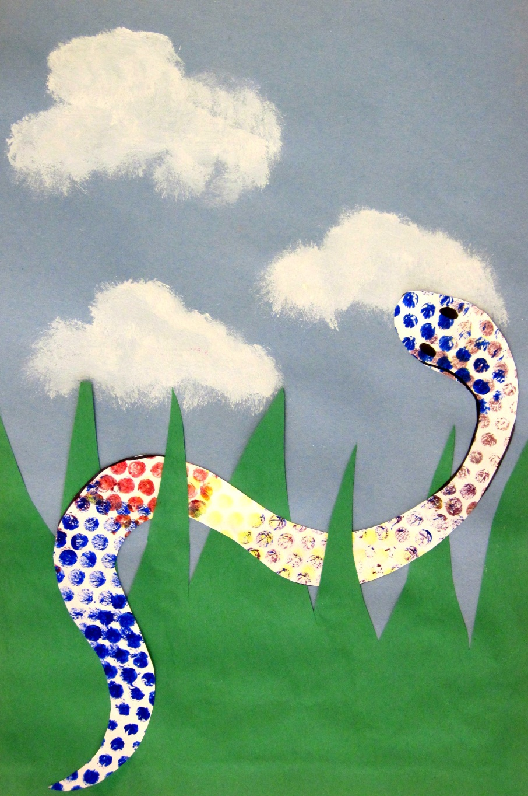

A. Where Art Classroom

B. Grade/Student Level Kindergarten

C. Class/Date/Times Two 50 minute periods

D. Room Description Art Room

**II. CURRICULUM CONTENT:**

**Creative Expression and Communication**

Students create artworks that demonstrate understanding of materials, processes, tools, media, techniques and available technology. They understand how to use art elements, principles and images to communicate their ideas in a variety of visual forms.

**Grade Level Indicators:**

1. Explore and experiment with a variety of art materials and tools for self-expression.
2. Explore art elements to express ideas in a variety of visual forms (e.g., drawings, paintings and ceramics).
3. **General Description**

Students will use bubble wrap to print exciting textures on white sulfite paper. Then, they will use this patterned paper in a construction paper collage to create a worm’s-eye view scene of a snake in the grass.

1. **Cognitive Goals: (Bloom)**
2. Understands texture
   1. Creates texture of scales by printing with bubble wrap
   2. Verbally defines texture as the way that something feels or looks like it feels
3. Understands movement
   1. Creates movement by making wiggly snake shape
4. Understand relief Printmaking
   1. Use bubble wrap as a printing surface to create patterns and textures
5. **Affective Goals: (Krathwohl)**
6. Follows directions
   1. Cooperates with teacher’s instructions quickly
   2. Asks questions when necessary
   3. Completes task as instructed
7. Works independently
   1. Able to complete task without seeking excessive assistance
   2. Does not disrupt classmates with chatter or play
8. Works cooperatively
   1. Shares materials
   2. Shares space
9. **Psycho/Motor Skill Goals (Simpson)**
10. Prints with bubble wrap
    1. Brushes bubble wrap with thin layer of tempera paint
    2. Lays painted bubble wrap on white sulfit paper and presses gently to transfer paint
    3. Repeats with a variety of colors
11. Cuts paper
    1. Cuts snake along pre-drawn lines
    2. Cuts grass blades
12. Glues paper
    1. Uses the right amount of glue (“drippy glue is a bummer”)
    2. Places snake and grass in correct spots
13. **Vocabulary: defined**

**Texture:** The way something feels or looks like it feels

**Proportion:** The relationship in size between two or more things.

1. **Materials/Tools: quantity and quality specified**

**Note: materials listed for 45 students, 3 classes of 15**

* 45 sheets light blue construction paper, 12” x 18”
* 45 sheets white sulfite paper, 12” x 18”
* 4 paint palettes
* 15 foam brushes
* One bottle white tempera paint
* One bottle black tempera paint
* One bottle blue tempera paint
* One bottle red tempera paint
* One bottle yellow tempera paint
* 45 sheets green construction paper, 9” x 12”
* 15 bottles Elmer’s glue’
* 15 pairs scissors
* 15 White oil pastel sticks

1. **Teacher Resources**

* Pictures of snakes
* Teacher exemplar

1. **Bibliography**
   1. [www.odc.state.oh.us/curriculum-assessment/ci/](http://www.odc.state.oh.us/curriculum-assessment/ci/)
   2. [www. arteducators.org](http://www.arteducators.org)
   3. [www.oaea.org](http://www.oaea.org)
   4. http://www.deepspacesparkle.com/2011/01/snakes-in-the-grass/

**III. TEACHING STRATEGIES**

1. **Motivation:** (Artistic, Intellectual, Imaginative, **Kinesthetic**) describe

Students get to play with bubble wrap!

1. **Methodology/Procedures (Hunter)**
2. T prep:
   1. Set newspaper on ends of tables
3. T introduces project and idea of texture
   1. T defines texture as how something feels or looks like it feels
   2. T explains that animals have texture
      1. T asks S to come up with some animal textures
   3. T explains that snakes have a scaly texture, and that we’ll be printing to make scaly-looking paper for our snakes
4. T demos printing with bubble wrap
   1. T lays out sheet of newspaper
   2. T writes name on back of 12” x 18” white sulfite paper
   3. T uses sponge brush to apply thin layer of color to bubble wrap
   4. T presses bubble wrap onto paper
   5. T repeats with same color several times
   6. T repeats with other colors, keeping brush with color each time to avoid having to wash brush
5. S print with bubble wrap as demonstrated by T
   1. T has S volunteer distribute white sulfite paper
   2. T has S volunteer distribute bubble wrap and brushes
   3. T reminds S to write name and class number on back of paper before printing
   4. S print until paper is mostly covered with pattern, then leave finished prints in drying rack
6. S begin to create backgrounds
   1. T has S volunteer distribute light blue construction paper
      1. T reminds S to write name and class number on back of paper
   2. T has S draw clouds on top half of paper with white oil pastels
7. Clean-up
   1. S leave finished work in drying rack.
   2. Clean-up procedure as usual (discard newspaper, wash tables, sweep, etc.)

**********************DAY TWO**********************

1. T demos next steps of project
   1. T creates snake
      1. T draws a big fat twisty snake on back of printed paper in pencil
      2. T cuts along snake outline, turning paper into scissors
   2. T creates grass
      1. T uses 9” x 12” green construction paper and lines up with bottom edge of background
      2. T draws spiky grass blades into top of paper, leaving paper connected at bottom
      3. T cuts along drawn lines
   3. T assembles collage
      1. T weaves snake in and out of grass blades, then applies glue to backs of both pieces together
      2. T glues grass in place at bottom of background.
2. T distributes S work from previous class
3. S finish project as demonstrated by T
4. Clean-up
   1. S leave finished work in drying rack.
   2. Clean-up procedure as usual (wash tables, sweep, etc.)

C. Discipline Model Description (Canter)

**IV. ASSESSMENT/EVALUATION:** critical analysis of observed results

**Observation Criteria:**

* Student is on-task and working
* Student does not distract others
* Student works carefully (e.g. does not spill paint on floor)

**Oral Assessment:**

* What is texture? (Or, alternatively, what is the word for how something feels?)
* What is movement?

**Rubric**



**V. COMMENDATIONS AND RECOMMENDATIONS FOR FUTURE LESSONS**

* Provide S with some clean bubble wrap to pop—do not encourage them to pop messy bubble wrap, as it makes clean up chaotic
* Stagger clean-up—allow those who finish earlier to begin cleaning (and washing their hands) immediately, as this is time-consuming
* Tell S to make snake by writing a big letter S—this helps them understand how to make the curve big, not small.