**Lesson Plan/Format**

NAME Dina Hoeynck COURSE INSTRUCTOR

**I. PROJECT TITLE:**  Snowy Penguins

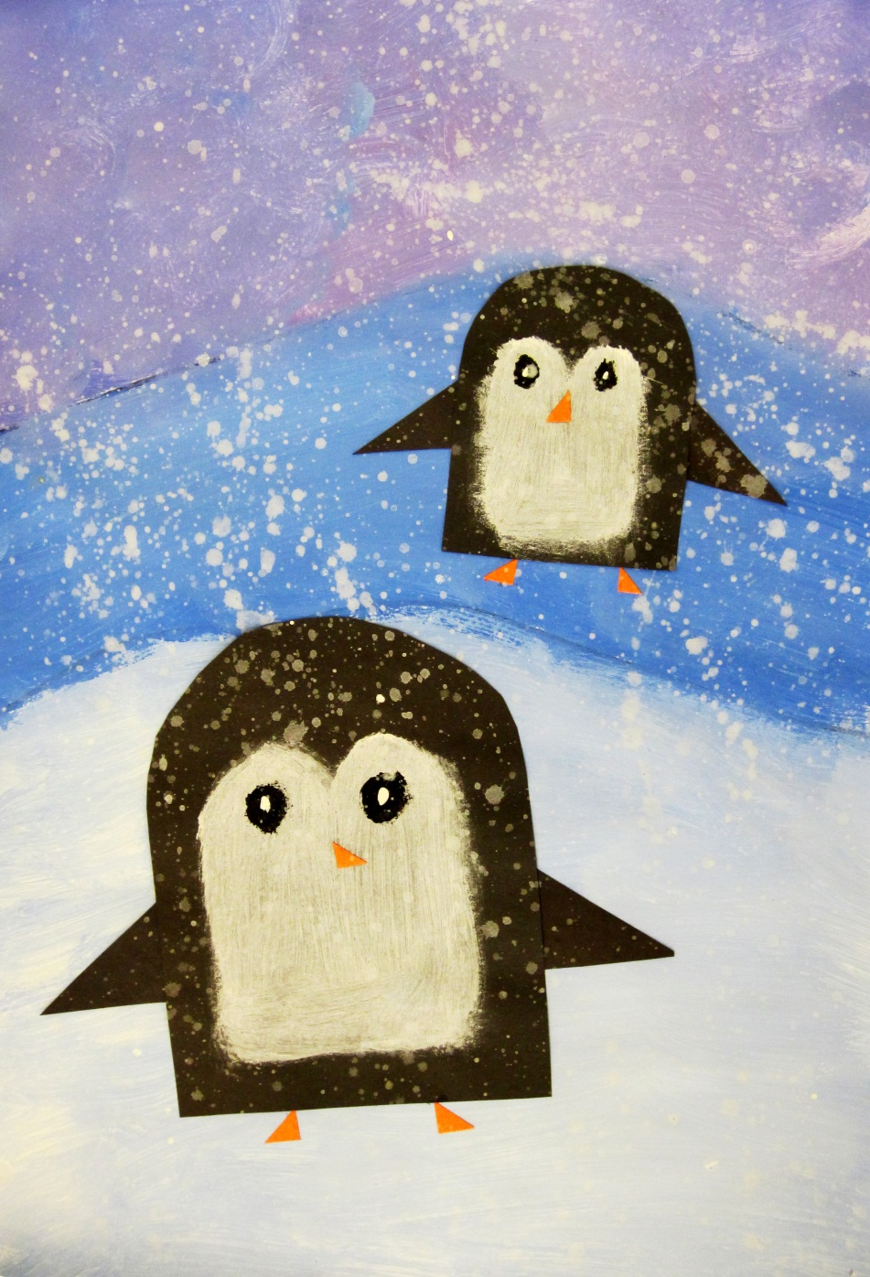

A. Where Art Classroom

B. Grade/Student Level Kindergarten

C. Class/Date/Times Three 50 minute periods

**II. CURRICULUM CONTENT:**

**Creative Expression and Communication**

Students create artworks that demonstrate understanding of materials, processes, tools, media, techniques and available technology. They understand how to use art elements, principles and images to communicate their ideas in a variety of visual forms.

**Grade Level Indicators:**

1. Explore and experiment with a variety of art materials and tools for self-expression.
2. Explore art elements to express ideas in a variety of visual forms (e.g., drawings, paintings and ceramics).
3. **General Description**

Each student will paint two snowy hills and a purple sky. Then, they will use templates to make two cut paper penguins, one small and one large. They will glue the large penguin on the front hill and the small penguin on the back, and decorate both with paint and cut paper. Finally, they will splatter the finished picture with white paint for snow.

1. **Cognitive Goals: (Bloom)**
2. Understands space
   1. Creates space in the composition by placing the big penguin on the lower hill
3. Understands unity
   1. Creates unity by mixing white in every part of the background
   2. Creates unity by splatter-painting in white over the top of the finished work
4. **Affective Goals: (Krathwohl)**
5. Follows directions well
   1. Cooperates with teacher’s instructions quickly
   2. Asks questions when necessary
   3. Completes task as instructed
6. Works independently
   1. Able to complete task without seeking excessive assistance
   2. Does not disrupt classmates with chatter or play
7. Works cooperatively
   1. Shares materials
   2. Shares space
8. **Psycho/Motor Skill Goals (Simpson)**
9. Traces penguin templates
   1. Places template on black construction paper
   2. While holding template still with non-dominant hand, uses dominant hand to trace around template with white colored pencil
10. Blends paints to paint background
    1. Dips brush in a lot of white and a little bit of blue
    2. Places brush in center of hill and brushes back and forth, blending paint on paper
    3. Repeats for second hill and sky
       1. For sky, adds magenta paint and creates circles “like a mop”
11. Cuts paper
    1. Cuts traced penguins smoothly along lines by turning paper into scissor blades
    2. Cuts triangles evenly
12. Glues paper
    1. Uses the right amount of glue (“drippy glue is a bummer”)
    2. Places penguins in correct spots
    3. Places penguins wings, beaks, and feet in correct spots
13. **Vocabulary: defined**

**Space:** Space is the sense of depth in a picture. Space can be created by making objects in the foreground bigger than objects in the background, by overlapping, or by making objects in the foreground more detailed or brighter than objects in the background.

**Cool Colors:** The cool colors are blue, green, and purple. We are using two of the cool colors in our penguin picture.

**Tint:** A tint is a light version of a color created by mixing it with white.

1. **Materials/Tools: quantity and quality specified**

**Note: materials listed for 45 students, 3 classes of 15**

* 45 sheets white sulfite paper, 12” x 18”
* 15 Sharpie markers
* 4 paint palettes
* 15 large bristle brushes
* 15 small paintbrushes
* One bottle white tempera paint
* One bottle black tempera paint
* One bottle blue tempera paint
* One bottle magenta tempera paint
* 60 sheets black construction paper, 9” x 12”
* 5 sheets orange construction paper, 9” x 12”
* 15 bottles Elmer’s glue

1. **Teacher Resources**

* Penguin templates made of heavy card stock
* Teacher exemplar
* Penguin videos (http://video.nationalgeographic.com/video/kids/animals-pets-kids/birds-kids/penguin-emperor-parenting-kids/)

1. **Bibliography**
   1. [www.odc.state.oh.us/curriculum-assessment/ci/](http://www.odc.state.oh.us/curriculum-assessment/ci/)
   2. [www. arteducators.org](http://www.arteducators.org)
   3. [www.oaea.org](http://www.oaea.org)
   4. http://video.nationalgeographic.com/video/kids/animals-pets-kids/birds-kids/penguin-emperor-parenting-kids/

**III. TEACHING STRATEGIES**

1. **Motivation:** (Artistic, Intellectual, **Imaginative**, **Kinesthetic**) describe

Students get to practice walking like a penguin.

1. **Methodology/Procedures (Hunter)**
2. T prep:
   1. Create templates for penguins.
   2. Set newspaper on ends of tables
3. T introduces project, asks students what they know about penguins
   1. T confirms that penguins are flightless birds, eat fish, etc.
4. T demos painting background
   1. T writes name on back of 12” x 18” white sulfite paper
   2. T uses sharpie to draw two hills
      1. T emphasizes that sharpie is permanent, and to not get it on the desks or yourselves
   3. T dips paintbrush in a lot of white paint and a little bit of blue
      1. T paints lower hill in light blue tint, blending paint right on the paper with back and forth strokes
   4. T dips paintbrush in a lot of white paint and a little more blue
      1. T paints back hill in medium blue tint, blending paint right on the paper with back and forth strokes
   5. T dips paintbrush in a lot of white paint, a bit of blue, and a bit of magenta (red, for students’ purposes)
      1. T blends paint right on paper using circular strokes, “like a mop”
5. S create backgrounds
   1. S spread newspaper over tables
   2. T has S volunteer distribute sulfite paper
   3. T has S volunteer distribute sharpies
   4. S write name and class # on back of paper
   5. S paint hills as demoed by T
6. Clean-up
   1. S leave finished work in drying rack.
   2. S who finish early complete penguin worksheet
   3. Clean-up procedure as usual (discard newspaper, wash tables, sweep, etc.)

**********************DAY TWO**********************

1. T prep
   1. Fill 4 palettes with white and black paint (more white, less black)
   2. Set aside templates, white colored pencils, black construction paper, and orange construction paper
   3. Mix up some 50% diluted white paint in cups
2. T demos next steps of project
   1. T places large penguin template all the way in one corner of sheet of 9” x 12” black construction paper, traces with white colored pencil
   2. T places small penguin template in other corner
   3. T cuts out 2 penguins, saving extra black paper
   4. T cuts remaining black paper into square, then cuts square in half
   5. T cuts each resulting rectangle into half diagonally to make penguin wings
   6. T glues small penguin on back hill and big penguin on front hill, then glues wings on each
      1. T glues wings at halfway point of penguin’s body, sticking straight out
   7. T uses white paint to paint tummy on each penguin
      1. T dips large brush in white paint and traces a shape right inside the penguin with a heart-like dip at the top
      2. T fills in shape with more white paint
   8. T uses small brush and black paint to paint eyes on each penguin
      1. T dips small brush in black paint and, holding brush like a pencil, draws a small circle where each eye should go, then fills in circle with more black paint.
      2. T rinses brush and adds a white dot in center of circle (optional)
   9. T cuts corners off orange construction paper square to create beaks and feet for penguins
      1. T glues down beaks and feet on penguins.
3. Distribution of supplies
   1. T has S volunteer distribute black paper
   2. T has S volunteer distribute white colored pencils
   3. T has S volunteer distribute one each of small and large brushes
   4. T distributes templates (one set per two S) and paint (one per 4 S)
4. S proceed as demoed
   1. S cut penguins, glue etc.
5. T circulates room, distributing orange paper as students become ready for it.
6. When S are 90% finished, T demos creating snow
   1. T dips brush into thinned white paint and smacks brush against side of hand to create splatter on paper
   2. T emphasizes being very careful while doing this to not get paint on neighbors.
   3. T explains that snow will create unity in artwork
   4. T sets up “splatter paint zone” in drying area
      1. T spreads newspaper over large area of floor, and S may use this area to splatter paint when finished.
7. S splatter paint pictures, clean up.
8. S watch penguin video if time permits.

C. Discipline Model Description (Canter)

**IV. ASSESSMENT/EVALUATION:** critical analysis of observed results

**Observation Criteria:**

* Student is on-task and working
* Student does not distract others
* Student works carefully (e.g. does not spill paint on floor)

**Oral Assessment:**

* What do we call a color mixed with white? (correct answer: tint)
* What is unity? (correct answer: when everything looks like it goes together)

**Rubric**



**V. COMMENDATIONS AND RECOMMENDATIONS FOR FUTURE LESSONS**

* Students finished at different times on day one, so I created a worksheet for those who finished early
* It is unfeasible to try to save newspaper with kindergartners, and far easier to simply have them throw it out.