**Lesson Plan/Format**

NAME Dina Hoeynck COURSE INSTRUCTOR

**I. PROJECT TITLE:**  Colored Pencil Mandalas

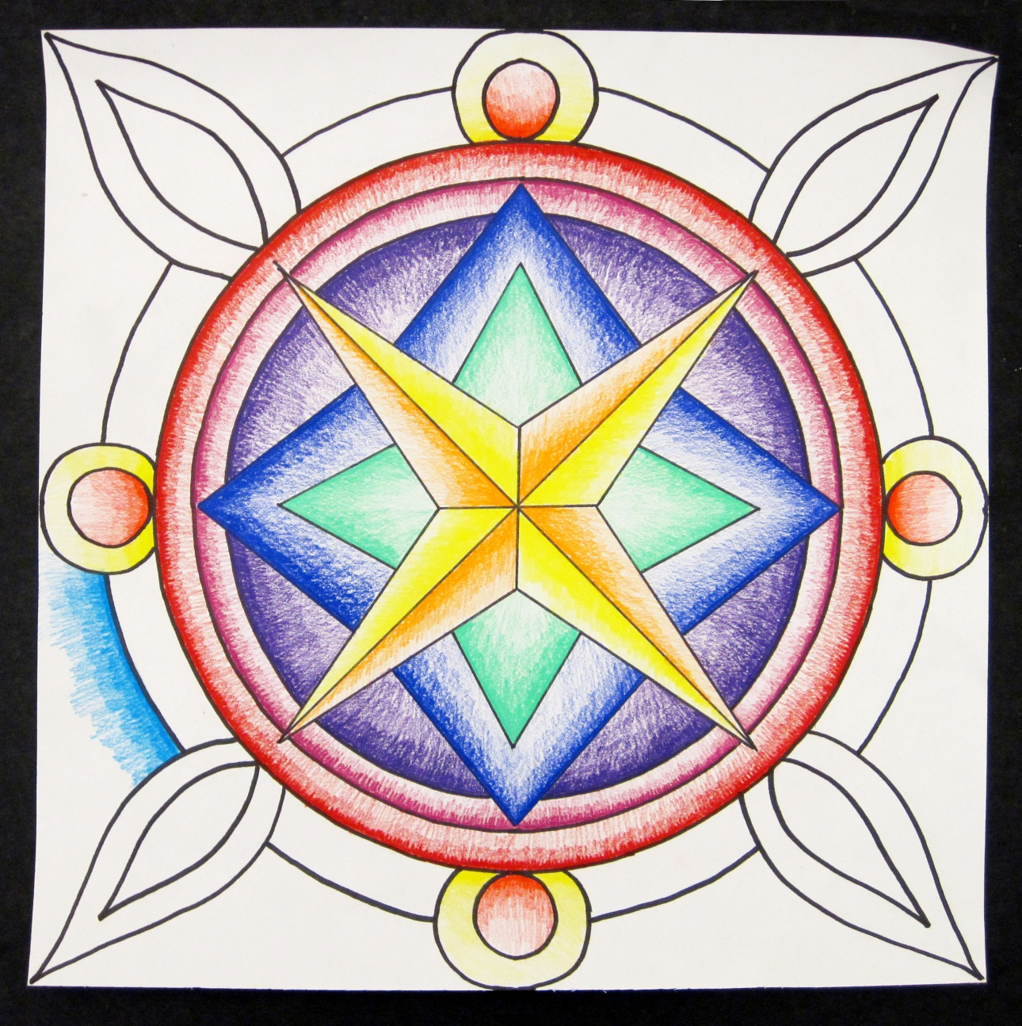

A. Where Art Classroom

B. Grade/Student Level 3rd/4th Grade

C. Class/Date/Times Three 50 minute periods

D. Room Description

**II. CURRICULUM CONTENT:**

**Creative Expression and Communication**

Students create artworks that demonstrate understanding of materials, processes, tools, media, techniques and available technology. They understand how to use art elements, principles and images to communicate their ideas in a variety of visual forms.

**3rd Grade Level Indicators:**

1. Demonstrate skill and expression in the use of art techniques and processes.
2. Use appropriate visual art vocabulary when describing art-making processes.
3. Recognize and identify a purpose or intent for creating an original work of art.
4. Identify relationships between selected art elements and principles (e.g., color and rhythm).

**4th Grade Level Indicators:**

1. Discuss their artworks in terms of line, shape, color, texture and composition.
2. Initiate and use strategies to solve visual problems (e.g., construct three dimensional art objects that have structural integrity and a sense of completeness).
3. **General Description**

Teacher will expose students to Buddhist and Hindu Mandalas, explaining that they display radial symmetry, with four identical quadrants. Students will then make their own mandalas. They will learn how to vary their pressure using colored pencils to fill each section of the mandala with a gradient of one color that moves from dark to light.

1. **Cognitive Goals: (Bloom)**
2. Understand element of value
   1. Create gradients that demonstrate a range of possible values for each color
3. Understand principle of balance
   1. Identify radial symmetry in examples of mandalas
   2. Create mirror symmetry in mandala project
4. Understand cultural relevance of mandalas
   1. Understand that mandalas are created as objects of meditation
   2. Explain that meditation means thinking about something without talking or acting.
5. **Affective Goals: (Krathwohl)**
6. Follows directions well
   1. Cooperates with teacher’s instructions quickly
   2. Asks questions when necessary
   3. Completes task as instructed
7. Works independently
   1. Able to complete task without seeking excessive assistance
   2. Does not disrupt classmates with chatter or play
8. Works cooperatively
   1. Shares materials
   2. Shares space
9. **Psycho/Motor Skill Goals (Simpson)**
10. Create value shifts by varying pressure of colored pencil
    1. Creates gradient by varying pressure of colored pencil evenly from one end of segment to the other
    2. Creates a gradual shift in value, covering all possible values in between
    3. Values range from lightest possible to darkest possible for each color
11. Outlines shapes of mandala smoothly using sharpie
    1. Traces carefully and slowly to make lines that are even and smooth
12. Creates symmetrical shapes in mandala
    1. Controls pencil to ensure that shapes are the same all the way around
13. **Vocabulary: defined**

**Mandala:** A decorative motif used in Hindu and Buddhist cultures for contemplation during meditation.

**Value**: The lightness or darkness of a color

**Meditation:** The practice of sitting quietly and emptying your mind of all thoughts.

**Symmetry:** Symmetrical images are the same in multiple directions.

**Radial Symmetry**: Images with radial symmetry are identical from the center outwards.

**Line of symmetry**: the imaginary line in which two sides of a symmetrical image meet. Mandalas have two lines of symmetry.

1. **Materials/Tools: quantity and quality specified**

**Note: materials listed for 80 students, 4 classes of 20**

* 80 sheets white sulfite paper, 12” x 12”
* A few good-sized mixing bowls, Frisbees, etc (for tracing circles)
* 2 dozen sharpie markers
* Colored pencil Classpack
* 20 #2 pencils with erasers

1. **Teacher Resources**

* Slideshow of Mandalas
* Teacher exemplar
* Mandala coloring sheets (for extending the learning)

1. **Bibliography**
   1. [www.odc.state.oh.us/curriculum-assessment/ci/](http://www.odc.state.oh.us/curriculum-assessment/ci/)
   2. [www. arteducators.org](http://www.arteducators.org)
   3. [www.oaea.org](http://www.oaea.org)
   4. <http://en.wikipedia.org/wiki/Mandala>
   5. http://groups.csail.mit.edu/graphics/mandala2009/timelapse.php

**III. TEACHING STRATEGIES**

1. **Motivation:** (**Artistic**, Intellectual, Imaginative, Kinesthetic) describe

Students will create beautiful, brightly colored designs.

1. **Methodology/Procedures (Hunter)**
2. T begins lesson by showing images of mandalas
   1. T explains that mandalas are used in Buddhist meditation practices
   2. T asks, “Does anyone know what meditation is?”
      1. S answer
   3. T explains that meditation means sitting quietly and emptying your mind of all thoughts
   4. T shows time-lapse video of sand mandala creation from MIT (http://groups.csail.mit.edu/graphics/mandala2009/timelapse.php)
3. T introduces art terms for lesson—symmetry, gradient, and value
   1. T asks S what symmetry is (building from previous lesson)
      1. S answer same on both sides
   2. T says, “Right, well these are the same all the way around, which is called radial symmetry”
      1. “You can remember that because it’s like the sun’s rays”
   3. T defines gradient, shows examples
   4. T defines value, explains that gradients should m
4. T demos project on ELMO
   1. T measures 6” in on each side of paper, marks with pencil
      1. T connects pencil marks to make a cross shape
      2. T connects center point to corners of paper to make an X
   2. T uses compass to make a circle
      1. T places compass point in center of paper, draws circle by rotating free side of compass
   3. T makes a design in one section (e.g. a diamond) then copies that into each other section by measuring the distance from center and repeating
      1. T continues until several designs have been placed down
      2. T demos tracing with sharpie
         1. T uncaps sharpie and, pressing only lightly, follows over existing lines.
            1. T uses ruler when tracing straight lines
5. S begin project
   1. T has S volunteers distribute paper
   2. T reminds S to write their name and class # on the back when they receive their paper.
   3. S begin working as demoed by teacher
6. T asks S to leave work on counter, clean up

*********************DAY TWO*********************

1. T demos making gradients
   1. On T exemplar from previous class, T picks one section to color in
   2. On ELMO, T demonstrates making a gradient by pressing firmly, then with decreasing pressure
      1. T emphasizes that transitions should be gradual
2. T asks S volunteer to return S work from previous day
3. S continue working on mandalas, coloring when appropriate.

*********************DAY THREE*********************

1. S complete mandalas
2. S complete exit cards

C. Discipline Model Description (Canter)

**IV. ASSESSMENT/EVALUATION:** critical analysis of observed results

**Observational checklist:**

* Works intently with minimal conversation
* Stays in seat unless given permission to get up
* Creates mandala using demonstrated procedures

**Exit Card:**

Define in a sentence the meaning of the word “gradient.”

**Index card assessment:**

Students draw a gradual gradient stretching from one side to the other of an index card.



**V. COMMENDATIONS AND RECOMMENDATIONS FOR FUTURE LESSONS**

* Students could further explore the idea of meditation by writing and practicing their own mantras.
* Students could continue working on mandala by adding a second colored pencil color on top of each gradient.
* Students could practice color relationships on mandala coloring sheets