NAME Dina Hoeynck COURSE INSTRUCTOR

**I. PROJECT TITLE:**  Indonesian Shadow Puppets

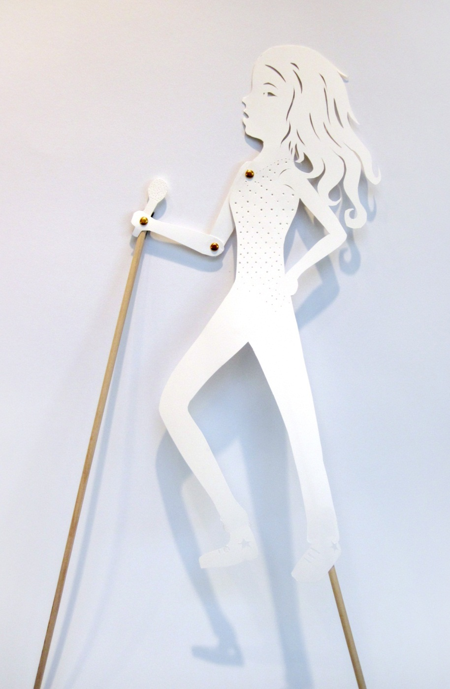

A. Where Art Classroom

B. Grade/Student Level 6th Grade

C. Class/Date/Times Two 50 minute periods

D. Room Description

**II. CURRICULUM CONTENT:**

**Creative Expression and Communication**

Students create artworks that demonstrate understanding of materials, processes, tools, media, techniques and available technology. They understand how to use art elements, principles and images to communicate their ideas in a variety of visual forms.

**Grade Level Indicators:**

Demonstrate skill in changing (e.g., exaggerating and transforming) natural forms for expressive purposes.

Use observation, life experiences and imagination as sources for visual symbols and images.

Recognize and demonstrate the qualities and characteristics of craftsmanship in original works of art.

Identify and defend artistic decisions using appropriate visual art vocabulary.

1. **General Description**

Students will use a slideshow of Indonesian shadow puppets and create their own puppets create shadow puppets inspired by Indonesian *Wayang Kulit* but using common American archetypal characters.

1. **Cognitive Goals: (Bloom)**
2. Understands shape.
   1. Defines shape orally
   2. Identifies shape orally in images of Indonesian shadow puppets
   3. Manipulates shape by exaggerating natural forms in creation of shadow puppet
3. Understands pattern
   1. Identifies pattern orally in images of Indonesian shadow puppets
   2. Analyzes use of pattern orally in images of Indonesian shadow puppets
   3. Applies pattern to decoration of shadow puppet
4. Understands concept of archetypes
   1. Contribute to list of archetypes written on board
   2. Creates shadow puppet based on an archetype
5. **Affective Goals: (Krathwohl)**
6. Demonstrates pride and respect for own creative endeavors
   1. Works with care and attention to detail
   2. Treats work-in-progress and finished work with care
7. Works neatly and cooperatively
   1. Cleans up after self
   2. Shares supplies
   3. Shares workspace
8. Works independently
   1. Completes all aspects of project without outside pressure
   2. Practices skills needed to succeed in project
9. **Psycho/Motor Skill Goals (Simpson)**
10. Cuts components for shadow puppet
    1. Uses scissors to cut outside edges
    2. Uses exacto knife to cut interior shapes and details
11. Decorates shadow puppet with pattern
    1. Controls awl to make neatly perforated lines
    2. Pattern is decorative and aesthetically pleasing
12. Assembles shadow puppet
    1. Attaches dowel securely
    2. Creates joints that move smoothly
13. **Vocabulary: defined**

**Shape**: the use of areas in two dimensional space that can be defined by edges, setting one flat

specific space apart from another. Shapes can be organic or geometric.

**Organic**: Having curved, freeform edges, such as an object found in nature.

**Geometric**: Having angular or mechanical edges, such as a manmade object.

**Archetype:** A universal character type, like a hero, witch, or rockstar.

**Pattern**: The repetition of an element of art resulting in a decorative effect.

**Proportion**: A principle of art; the size relationship between two or more objects or shapes.

Proportion is important when creating figures such as these puppets.

1. **Materials/Tools: quantity and quality specified**

* 15 no. 2 pencils
* 15 pink erasers
* 30 sheets heavy tagboard
* 1 ream basic drawing paper
* 15 thin dowels (1/4” diameter by 48” length)
* 15 pairs of good scissors
* 15 awls or compass-points
* 15 exacto knives
* 15 utility knives
* 15 cutting mats
* 4 boxes brass paper fasteners
* 1-2 rolls Duct tape
* A small saw (for cutting dowels—to be used by teacher only)

1. **Teacher Resources**
   1. Digital projector or smart board*
   2. Powerpoint slideshow of *Wayang Kulit\**
   3. Laptop or other computer for running slideshow*
   4. Teacher exemplar

*for use in preceding art history lesson, but may be referred to during art production portion.

1. **Bibliography**
   1. [www.odc.state.oh.us/curriculum-assessment/ci/](http://www.odc.state.oh.us/curriculum-assessment/ci/)
   2. [www. arteducators.org](http://www.arteducators.org)
   3. [www.oaea.org](http://www.oaea.org)
   4. [www.artstor.org](http://www.artstor.org)
   5. <http://en.wikipedia.org/wiki/Wayang>

**III. TEACHING STRATEGIES**

1. **Motivation**: (**Artistic**, Intellectual, Imaginative, Kinesthetic) describe

Artistic expression through creation of shadow puppets and application of decorative pattern.

**B. Methodology/Procedures (Hunter)**

**Note: I have included the methodology for the preceding art history lesson, because it includes the students’ drawing their preliminary sketches for the art production lesson.**

**\*\*\*\*\*\*\*\*\*\*\*\*\*\*\*\*\*\*\*\*\*\*\*\*\*\*\*\*\*\*PRECEDING LESSON\*\*\*\*\*\*\*\*\*\*\*\*\*\*\*\*\*\*\*\*\*\*\*\*\*\*\*\*\*\***

1. S view a slideshow of Indonesian Shadow puppets, or *Wayang Kulit*.
   1. T reminds S of definitions of shape and pattern
   2. T asks S to identify shapes in puppet
      1. S respond
   3. T asks S to identify patterns in puppet
      1. S respond
   4. T explains that these puppets are used in theatrical performances, and that each puppet represents a different type of character.
2. T introduces concept of archetypes
   1. T names “hero” and “villain” as examples of archetypes
   2. T asks S to volunteer archetypes
      1. S respond
      2. T writes all valid S responses on board
3. T discusses exaggeration of features
   1. T asks S “How do we know a character is a villain by looking at them?”
      1. S respond
   2. T prompts S to think about cartoon characters that might have exaggerated features.
4. T asks S to pick one archetype off of the list and think about what it might look like while T distributes materials.
   1. T reminds S to think about what features they might exaggerate for that archetype.
5. S draw preliminary sketches for puppets
   1. T distributes drawing paper, pencils, and erasers
   2. T asks S to write their name and the archetype they’ve chosen at the top of the page
   3. T asks S to sketch three variations on their archetype.
      1. T reminds S to exaggerate some features so the viewer will know what their archetype is.
      2. T reminds S to consider how this puppet will move.
         1. Puppet must have one moving limb (see exemplar)
6. T collects and evaluates S drawings.

**\*\*\*\*\*\*\*\*\*\*\*\*\*\*\*\*\*\*\*\*\*\*\*\*\*\*\*DAYS ONE & TWO\*\*\*\*\*\*\*\*\*\*\*\*\*\*\*\*\*\*\*\*\*\*\*\*\*\*\***

1. Before class, T lays out all materials on tables
   1. tagboard, pencils, erasers, scissors, cutting mats
2. T demos safe use of exacto knives
   1. Place tagboard over cutting mat
   2. Place knife tip down on surface of board
   3. Draw knife slowly towards yourself, making sure fingers are not in the path of knife
3. T returns S drawings with comments & suggestions
4. S re-draw best image on tagboard using hard (#2) pencil
   1. S sketch image lightly to get correct overall shape
   2. S use kneaded eraser to correct mistakes
   3. S finish re-drawing image by defining details of figure
5. S cut out puppet
   1. S use scissors for outside of puppet
      1. T demonstrates turning the paper into your scissors rather than turning the scissors.
   2. S may request an exacto knife from T after demonstrating they can use it safely.
   3. S punch holes for hinges in puppet following T demonstration
      1. S mark point for hole with pencil
      2. S place puppet down on cutting board and pierce pencil mark with awl
      3. S wiggle tag board up onto awl to enlarge the hole
6. T discusses pattern with S
   1. T defines pattern as a repeating arrangement of shapes or dots
   2. T demonstrates techniques for making pattern in paper
      1. T punches tagboard with rows of dots
      2. T punches tagboard with grid of dots
      3. T punches tagboard with wavy lines of dots
      4. T cuts diamonds out of tagboard using exacto knife
         1. T reiterates that to use an exacto knife S must demonstrate safe use.
7. S decorate puppets
   1. T reminds S to ensure that the pattern does not weaken the puppet by removing too much material.
   2. S use awl or compass to punch patterns
   3. S use exacto knife to cut patterns
8. S assemble puppets
   1. S use brass paper fastener to attach upper arm to body
      1. Insert arms of brass fastener through both holes
      2. Bend arms back once
      3. Fold fastener arms back in on themselves so they do not extend beyond edge of puppet’s arm
   2. S uses brass paper fastener to attach forearm to upper arm
      1. Insert arms of brass fastener through both holes
      2. Bend arms back once
   3. Fold fastener arms back in on themselves so they do not extend beyond edge of puppet’s arm
   4. S attaches dowel
      1. S holds dowel up to puppet and measures lengths needed
      2. S marks lengths on dowel
      3. T cuts dowel with saw
      4. S attaches dowel to body with duct tape
      5. S attaches dowel to hand
         1. S inserts brass fastener in hand
         2. S wraps arms of fastener around dowel
         3. S secures dowel to fastener with duct tape
9. Clean up
   1. S writes name on back of finished puppet
   2. S clear tables of any scrap paper, punched holes, etc.
   3. S and T return supplies to storage

**C. Discipline Model Description (Canter)**

**IV. ASSESSMENT/EVALUATION:** critical analysis of observed results

Student activity sheet:

Name:________________________________________________ Class:___________________

**Indonesian-Inspired Shadow Puppets**

1. Name the archetype you chose:___________________________________________________
2. Name three specific characters from books, movies, etc. that are examples of this archetype:
   1. ____________________________________________________
   2. ____________________________________________________
   3. ____________________________________________________
3. What physical features or accessories did you include that tell the viewer what archetype your puppet is?
   1. ____________________________________________________
   2. ____________________________________________________
   3. ____________________________________________________
4. Name one place on your puppet where you used negative space to create shapes: _________________________________________________________________________________
5. If you could add accessories for your archetype, what would they be?
   1. ____________________________________________________
   2. ____________________________________________________
   3. ____________________________________________________
6. What genre of story would your archetype appear in? __________________________________________________________________________________
7. On the back, write a short story for your archetype.

Rubric:



**Oral Evaluations:**

* In-class archetype brainstorming activity
* Verbal assessment for definition of archetype/examples and non-examples of archetypes

**V. COMMENDATIONS AND RECOMMENDATIONS FOR FUTURE LESSONS**

* Explain construction of limbs in greater detail. Many students had difficulty understanding that limb section needed to be long enough to allow room for brads
* let students practice cutting on a small, pre-defined template to help them understand how they will be using positive and negative shapes (so they won’t slice through their actual puppets, as some did)