**Lesson Plan/Format**

NAME Dina Hoeynck COURSE INSTRUCTOR

**I. PROJECT TITLE:**  Gyotaku

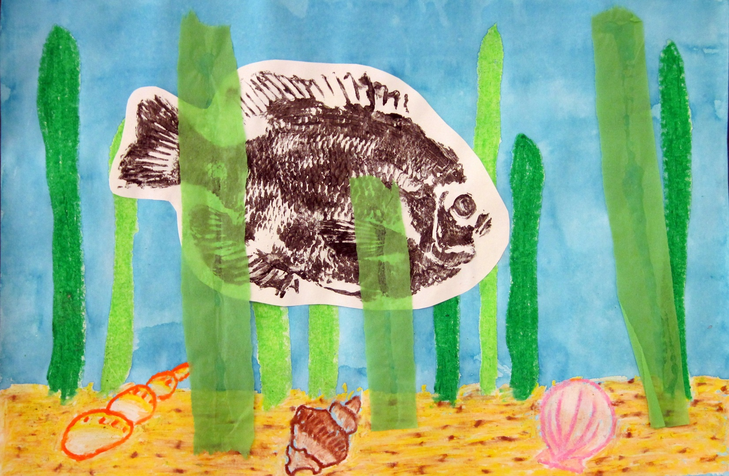

A. Where Art Classroom

B. Grade/Student Level 1st/2nd Grade

C. Class/Date/Times Two 50 minute periods

D. Room Description

**II. CURRICULUM CONTENT:**

**Creative Expression and Communication**

Students create artworks that demonstrate understanding of materials, processes, tools, media, techniques and available technology. They understand how to use art elements, principles and images to communicate their ideas in a variety of visual forms.

**1st Grade Level Indicators:**

1. Demonstrate beginning skill in the use of art materials and tools.
2. Explore and use a range of subject matter (e.g., people, places, animals and nature) to create original works of art .

**2nd Grade Level Indicators:**

1. Demonstrate increasing skill in the use of art tools and materials.
2. Create artworks based on observation of familiar objects and scenes in the environment.

[**Life Sciences**](http://ohiorc.org/standards/ohio/item/science/standard/45.aspx)  
Students demonstrate an understanding of how living systems function and how they interact with the physical environment. This includes an understanding of the cycling of matter and flow of energy in living systems. An understanding of the characteristics, structure, and function of cells, of organisms and of living systems are developed as well as a deeper understanding of the principles of heredity, biological evolution, and the diversity and interdependence of life. Students also demonstrate an understanding of different historical perspectives, scientific approaches and emerging scientific issues associated with the life sciences.

**1st Grade Level Indicators:**

1. Explore that organisms, including people, have basic needs which include air, water, food, living space and shelter.
2. Explore that humans and other animals have body parts that help to seek, find and take in food when they are hungry (e.g., sharp teeth, flat teeth, good nose, sharp vision).
3. Investigate that animals eat plants and/or other animals for food and may also use plants or other animals for shelter and nesting.

**2nd Grade Level Indicators:**

* 1. Explain that animals, including people, need air, water, food, living space and shelter, and plants need air, water, nutrients (e.g., minerals), living space and light to survive.
  2. Identify that there are many distinct environments that support different kinds of organisms.
  3. Investigate the different structures of plants and animals that help them live in different environments (e.g., lungs, gills, leaves and roots).

1. **General Description**

Students will use oil pastels and watercolor resist to create ocean backgrounds, then create gyotaku, or Japanese fish prints, in black tempera paint on separate pieces of paper. On the second day of the lesson, students will cut out their gyotaku and glue them onto the background, adding green tissue paper for “seaweed.”

1. **Cognitive Goals: (Bloom)**
2. Understand art element of texture
   1. Distinguish between real and implied texture in an exit quiz
   2. Create implied texture through relief printing
3. Understand the art principle of emphasis
   1. Create emphasis in a work of art by pasting black tempera fish onto watercolor wash background
4. Understand relief printmaking
   1. Create a relief print in the Japanese tradition of gyotaku
5. **Affective Goals: (Krathwohl)**
6. Follows directions well
   1. Cooperates with teacher’s instructions quickly
   2. Asks questions when necessary
   3. Completes task as instructed
7. Works independently
   1. Able to complete task without seeking excessive assistance
   2. Does not disrupt classmates with chatter or play
8. Works cooperatively
   1. Shares materials
   2. Shares space
9. **Psycho/Motor Skill Goals (Simpson)**
10. Create a gyotaku print
    1. Apply tempera paint lightly to fish using foam brush
    2. With the assistance of a partner, line up paper and lay gently onto fish
    3. Using fingertips, gently press paper onto fish, feeling for shapes of scales
       1. Press without shifting paper.
11. Create a watercolor wash
    1. Blend paint with water using a large brush
    2. Brush paint onto paper
    3. Add more water to make paint bleed across paper
12. Create a watercolor resist using oil pastels
    1. Push firmly and evenly to transfer pastel to paper with smooth coverage
    2. Apply pastel evenly across paper, covering all white dots.
13. **Vocabulary: defined**

**Gyotaku:** A Japanese method of making a print from a fish

**Print:** 2-D artwork that can be made the same way again and again

**Texture**: The way a surface feels, or looks like it would feel. The fish has real texture, and the print of the fish has implied texture.

**Real Texture**: The way a 3-D surface actually feels

**Implied Texture**: The way a 2-D surface looks like it would feel if it were 3-D

**Emphasis**: A principle of art; an image is emphasized in a work of art when it catches your attention first.

1. **Materials/Tools: quantity and quality specified**

**Note: materials listed for 80 students, 4 classes of 20**

* 10 rubber fish for gyotaku
* 20 foam brushes
* Assorted oil pastels
* One bottle black tempera paint
* One full bottle blue liquid watercolor paint
* 6 plastic palettes for paint
* 6 plastic container or bowls for water
* 160 sheets 12” x 18” white sulfite paper

1. **Teacher Resources**

* Teacher exemplar
* Realia
  + Dried Starfish
  + Shells
* Slideshow of images from http://www.hawaiibeachcombers.com/gyotaku.html
* worksheet matching textures to the animals they come from

­

1. **Bibliography**
   1. [www.odc.state.oh.us/curriculum-assessment/ci/](http://www.odc.state.oh.us/curriculum-assessment/ci/)
   2. [www. arteducators.org](http://www.arteducators.org)
   3. [www.oaea.org](http://www.oaea.org)
   4. <http://ohiorc.org/standards/ohio/item/science/gli/45.aspx>
   5. <http://www.hawaiibeachcombers.com/gyotaku.html>
   6. http://www.hqoboi.com/eng/other_026.html

**III. TEACHING STRATEGIES**

1. **Motivation:** (Artistic, Intellectual, Imaginative, **Kinesthetic**) describe

Kids will get to rub gently on rubber fish to create prints

1. **Methodology/Procedures (Hunter)**
2. T sets up before class
   1. T sets out paper
   2. T puts 4 foam brushes in each tote
   3. T sets newspaper at end of each table
   4. T pours out palettes with black tempera paint, sets aside
   5. T sets aside rubber fish
3. T introduces project
   1. T explains that gyotaku is a type of printmaking they use in Japan, and that when a fisherman would catch a really great fish, he would use gyotaku to make a record of that fish so that he would have proof even after the fish was sold or eaten.
   2. T explains that we won’t use real fish, though, we’ll use rubber fish
4. T talks about ocean life
   1. T shows real starfish, shares facts about starfish
   2. T asks S why we can’t live underwater
      1. T explains that fish can live underwater because of their special body parts
         1. Gills let them breathe oxygen from the water
         2. Fins let them swim
         3. Scales make them sleek and smooth and protect them.
5. T demos oil pastel resist
   1. T draws sand, seaweed and shells using oil pastel on white sulfite paper
   2. T emphasizes firm, even pressure.
   3. T finishes drawing, then demos watercolor wash
      1. T dips foam brush in diluted blue watercolor
      2. T covers background with blue wash
6. S make backgrounds for gyotaku
   1. T asks for S helpers to distribute white sulfite paper and oil pastels
   2. T distributes cups of blue watercolor
   3. T reminds S to put name and class number on back of paper before beginning
   4. S repeat process as demoed by T
      1. S draw sea floor and seaweed
      2. S wash with blue when finished
      3. S set aside to dry
7. T demos gyotaku
   1. T dips foam brush in tempera paint and paints a thin layer on rubber fish
      1. T explains to make sure to get the paint in all the little nooks an crannies of the fish, but don’t slop it on too thickly.
      2. T explains that the fish has an actual texture, but when we print it we will see an implied texture
   2. T asks student next to her to be her helper
      1. T asks student to help her put the paper on straight
      2. T lays paper down onto fish
   3. T prints fish with fingers
      1. T explains how to feel the little scales and textures of the fish through the paper, and try not to wiggle the paper while printing.
8. T asks S to return to seats
9. T asks S to be partners with the person next to them.
10. T asks for two volunteers from each table to cover the tables in newspaper.
11. T asks for a S volunteer to distribute paper
12. T distributes paint and fish
13. T reminds S to write their name and class number on the back of their paper before beginning
14. S print fish in pairs, each taking a turn
15. S put finished gyotaku on drying rack.
16. S clean up according to assigned roles
    1. S responsible for cleaning paint will also clean the paint off table’s fish

********************DAY TWO********************

1. T demos cutting out gyotaku
   1. On ELMO, T traces line around outside of gyotkau
   2. T cuts around gyotaku, following traced line
      1. T emphasizes turning the paper into the scissor vs turning the scissor.
2. T demos gluing gyotaku
   1. On ELMO, T flips over cut out gyotaku and lays a line of glue around edges of fish, then a squiggle through the middle.
   2. T glues fish onto exemplar background.
      1. Reminds S about emphasis
3. T demos gluing seaweed
   1. T tears strips of tissue paper and glues some to the left of, right of, and over the fish.
4. Distribution of materials
   1. T asks 2 S volunteers to distribute printed gyotaku
   2. T asks 2 S volunteers to distribute painted backgrounds
   3. T distributes tissue
5. S finish project as demoed by T

C. Discipline Model Description (Canter)

**IV. ASSESSMENT/EVALUATION:** critical analysis of observed results

**Observation Criteria:**

* Student is on-task and working
* Student does not distract others
* Student cooperates with partner during printing

**Exit Card:**

Name:______________________________

Class #:_____________________________

Next to each item, circle whether it is an example

of *real* or *implied* texture:

A piece of sandpaper: real implied

A painting of a grassy field: real implied

A photo of a dog’s fur: real implied

A bumpy clay sculpture: real implied

A fuzzy sweater: real implied



**V. COMMENDATIONS AND RECOMMENDATIONS FOR FUTURE LESSONS**

* S could use more than one fish in finished work
* 3 test prints was a lot—seems like a waste of paper. Maybe S could use ½ sheet of paper rather than a full sheet