**Lesson Plan/Format**

NAME Dina Hoeynck COURSE INSTRUCTOR

**I. PROJECT TITLE:**  Valentine Hearts

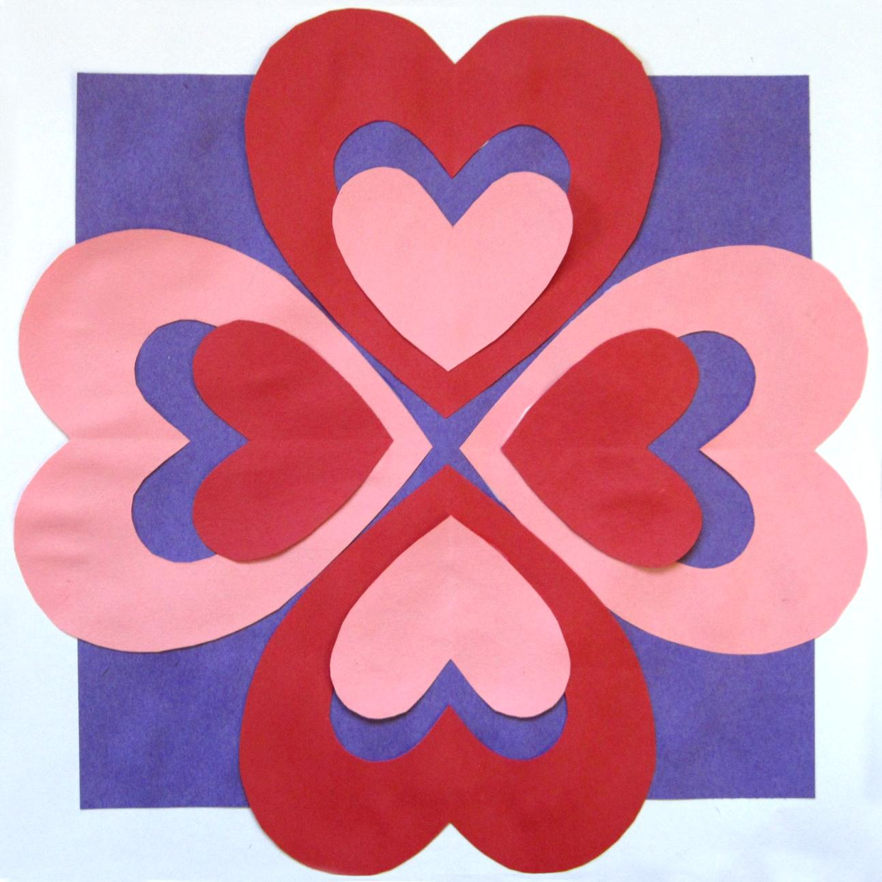

A. Where Art Classroom

B. Grade/Student Level Kindergarten

C. Class/Date/Times One 50 minute period

D. Room Description

**II. CURRICULUM CONTENT:**

**Creative Expression and Communication**

Students create artworks that demonstrate understanding of materials, processes, tools, media, techniques and available technology. They understand how to use art elements, principles and images to communicate their ideas in a variety of visual forms.

1. Explore and experiment with a variety of art materials and tools for self-expression.
2. Explore art elements to express ideas in a variety of visual forms (e.g., drawings, paintings and ceramics).
3. **General Description**

Students will use heart-shaped templates to create cut-paper hearts out of red and pink construction paper with negative interior shapes. Students will then glue these hearts down in a pattern with radial symmetry.

1. **Cognitive Goals: (Bloom)**
2. Understands element of shape
   1. Understands positive and negative shapes
   2. Creates positive and negative shapes in paper
   3. Identifies positive and negative shapes verbally
3. Understands symmetry
   1. Creates symmetrical shapes in cut paper
4. Understands pattern
   1. Creates pattern using cut paper
   2. Identifies pattern verbally
5. **Affective Goals: (Krathwohl)**
6. Follows directions well
   1. Cooperates with teacher’s instructions
   2. Asks questions when necessary
   3. Completes task as instructed
7. Works independently
   1. Able to complete task without seeking excessive assistance
   2. Does not disrupt classmates with chatter or play
8. Works cooperatively
   1. Shares materials
   2. Shares space
9. **Psycho/Motor Skill Goals (Simpson)**
10. Traces templates
    1. Folds paper in half
    2. Reopens paper
    3. Lays template over paper, then folds the two up together “like a sandwich”
    4. Traces only one side of template
11. Cuts heart
    1. Removes template from folded paper
    2. Cuts heart by turning paper with non-dominant hand while cutting with dominant hand
12. Glues paper into correct pattern
    1. Uses the right amount of glue (“not too much and not too little”) to get the paper to stick without having glue spill around edges
    2. Applies glue to smaller piece of paper
    3. Controls placement of paper to lay in correct spot in composition
13. **Vocabulary: defined**

* **Symmetry:** Something has symmetry when it looks the same on both sides
* **Balance:** Artwork with balance looks like if you held it from the middle, it wouldn’t tip left or right, but would be totally still. Symmetry is one way of creating balance.
* **Positive Shape:** The colored-in part of a shape.
* **Negative Shape:** The empty space inside a shape or around a shape.
* **Pattern:** Something that repeats (like “red, blue, red, blue”)

1. **Materials/Tools: quantity and quality specified**

**Note: materials listed for 45 students, 3 classes of 15**

* 90 6” x 6” squares red construction paper
* 80 6” x 6” squares pink construction paper
* 45 10” x 10” squares purple construction paper
* 45 12” x 12” squares white sulfite paper
* 15 bottles of white Elmer’s glue
* 15 pairs child-sized scissors
* 8 cardstock heart templates
* 15 pencils
* 45 large envelopes (for storing cut pieces between days one and two)

1. **Teacher Resources**

Teacher Exemplar

­

1. **Bibliography**
   1. [www.odc.state.oh.us/curriculum-assessment/ci/](http://www.odc.state.oh.us/curriculum-assessment/ci/)
   2. [www. arteducators.org](http://www.arteducators.org)
   3. [www.oaea.org](http://www.oaea.org)

**III. TEACHING STRATEGIES**

1. **Motivation:** (**Artistic**, Intellectual, Imaginative, Kinesthetic) describe

Students will make beautiful paper heart pictures that will serve as Valentine’s Day decorations.

1. **Methodology/Procedures (Hunter)**
2. T prep
   1. T sets out paper squares on counter
   2. T checks that there are enough glue bottles and scissors at each desk’s tote.
3. T introduces project
   1. T shows how when you fold a piece of paper in half and cut it with scissors, it comes out the same on both sides.
      1. T explains that this is symmetry, which is a word that means "looking the same on both sides.”
4. T demos cutting paper heart on ELMO
   1. T shows how to fold paper in half by lining up open edge, then pressing a nice crease in the paper with side of hand
   2. T reopens folded paper and lays template over it
   3. T folds paper and template together
   4. T traces template with pencil on one side only
      1. T asks, “Why do I only need to trace one side?
      2. T answers, because I’m going to cut it while it’s still closed.
   5. T removes template, cuts outside of heart, then inside
   6. T shows how this makes two shapes, a big heart and a little heart
      1. T explains that the empty space inside the big heart is negative space, and the heart around it is positive space
5. T asks for 2 volunteers to distribute materials
   1. T has one S give each S two pink sheets of paper, while another S gives each S two red sheets of paper.
6. T guides class through folding, tracing, and cutting their hearts.
7. T asks for two S volunteers
   1. One distributes white paper
   2. One distributes purple paper
8. T reminds S to write name and class number on back of white paper
9. T tells S to glue their purple paper lined up in the middle of their white paper “like this” and shows example at front of room
   1. T reminds S not to use too much or too little glue
10. S glue down big hearts
    1. T tells S they are going to make a pattern.
    2. T asks S to answer what a pattern is
    3. S answer
    4. T shows S the pattern for the big hearts
    5. T tells S to glue their hearts down in that pattern
       1. T reminds S to put the glue on the hearts, not the paper, because they wouldn’t want to get glue in… “What do we call this?” … negative space
11. S glue down little hearts
    1. T explains that they saved their little hearts so they could make their pattern look even better’
    2. T asks S if they glued the red on the red, would that make a pattern?
       1. No!
    3. Right! T tells S they will glue the pink on the red, and the red on the pink
    4. T tells S to move the little hearts towards the center of the picture (shows exemplar) so they can still see that awesome negative space inside
12. Cleanup
    1. S walk finished projects to drying rack
    2. S clean up table according to assigned roles

C. Discipline Model Description (Canter)

**IV. ASSESSMENT/EVALUATION:** critical analysis of observed results

**Observation Criteria:**

* Student is on-task and working
* Student does not distract others
* Student treats materials respectfully
* Student follows demonstrated procedures

**Oral Assessment:**

While circulating through room, ask each student to show the positive shape and negative shape on their heart.



**V. COMMENDATIONS AND RECOMMENDATIONS FOR FUTURE LESSONS**

* Advanced students may also use a hole punch to decorate their hearts
  + However, this does complicate gluing
* Lesson plan initially written for two days, but vast majority of students able to complete within one
* Some classes may need gluing procedure to be lock-stepped