Lesson Plan/Format

NAME Dina Hoeynck COURSE INSTRUCTOR

I. PROJECT TITLE: Surrealistic Dreamscapes

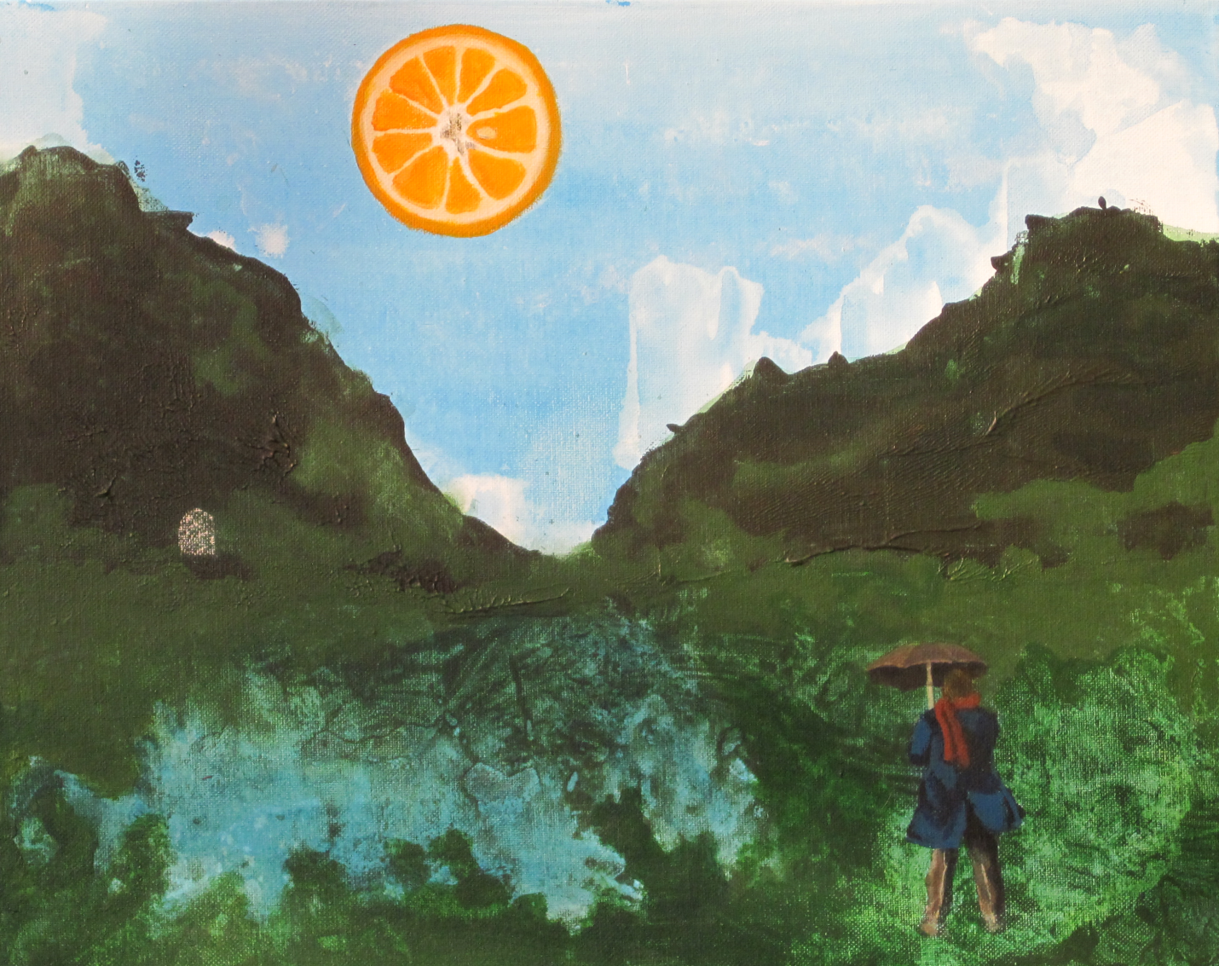

A. Where Art Classroom

B. Grade/Student Level 11th grade/ Advanced Painting

C. Class/Date/Times Ten 50 minute class periods

D. Room Description

II. CURRICULUM CONTENT:

Creative Expression and Communication
Students create artworks that demonstrate understanding of materials, processes, tools, media, techniques and available technology. They understand how to use art elements, principles and images to communicate their ideas in a variety of visual forms.

Grade Level Indicators:

1. Trace the origin of symbolism, imagery and metaphor in art and demonstrate the use of these visual devices in their artworks.

2. Evaluate their choices of compositional elements in terms of how those choices affect the subject matter of the work.

- General Description

Following an art history lesson in which students study and respond to Surrealist landscape paintings, the class will create their own Surrealist dreamscapes. They will develop their imagery using drawing and collage, then paint their “dreamscapes” in acrylic on canvas or canvas board.

- Cognitive Goals: (Bloom)

- Understand element of space
  - Create space in an original painting using multiple strategies:
    - Classical Linear Perspective
    - Objects in foreground have greater intensity than objects in background
    - Objects in foreground are more richly textured than objects in background
    - Objects in foreground are darker in value than objects in background

- Understand principle of unity
  - Unify disparate and incongruous elements of painting through use of a common palette
  - Unify disparate and incongruous elements of painting through use of a common style

- Understand Surrealism
  - Create a set of personal symbolic imagery
  - Draw inspiration from random chance
  - Combine randomly selected imagery and personally symbolic imagery in a landscape

- Affective Goals: (Krathwohl)

- Demonstrate pride and respect for own creative endeavors
  - Work with care, effort, and attention to detail
  - Treat work-in-progress and finished work with care

- Work neatly and cooperatively
  - Clean up after self
  - Share supplies
  - Share workspace

- Work independently
  - Complete all aspects of project without outside pressure
  - Practice skills needed to succeed in project

- Psycho/Motor Skill Goals (Simpson)

- Use surrealist painting technique of decalcomania
  - Smear paint in medium-thick layer on canvas
  - While paint is still wet, press large sheet of scrap paper over surface of paint
  - Peel off scrap paper, revealing new, random patterns
  - Allow to dry
  - Use these patterns as the basis for dream-like imagery

- Mix paint colors to create a unified palette
  - Blend colors using a pallete knife or other non-porous utensil
  - Blend colors fully before painting
  - Adjust colors as needed
  - Create shades by blending complementary colors

- Control paintbrush for accurate application of paint
  - Hold brush like a pencil for controlled application of paint
  - Blend brushstrokes while paint is still wet for a smooth, illusionistic effect

- Vocabulary: defined

Surrealism: A 20th-century avant-garde movement in art and literature that sought to release the
creative potential of the unconscious mind.
Space: An element of art, space refers to distances or areas around, between or within
components of a piece. Space can be positive (white or light) or negative (black or dark), open or closed, shallow or deep and two-dimensional or three-dimensional. Sometimes space isn't actually within a piece, but the illusion of it is.
Unity: A principle of art, unity occurs when all of the elements of a piece combine to make a
balanced, harmonious, complete whole. Unity is another of those hard-to-describe art terms but, when it's present, your eye and brain are pleased to see it.
Automatism: The use of chance in the creation of artworks, employed by Surrealists and
Dadaists.
Exquisite Corpse: A surrealist game of collaborative drawing.
Decalcomania: A Surrealist automatic painting technique, in which wet paint is pressed down
with paper and peeled away, leaving behind a random pattern much like a Rorschach ink
blot.
Grattage: A Surrealist painting technique involving the scraping away of paint, often after it had
already dried.
Frottage: A Surrealist drawing technique in which the artist makes a rubbing of a surface. The
resulting textures would then be used as a basis for drawing.
Eclaboussure: A surrealist painting technique in which solvent is dripped onto wet paint,
creating random patterns.

- Materials/Tools: quantity and quality specified
- Student Sketchbooks
- Ream of 16” x 20” newsprint sheets
- Ream of 16” x 20” white drawing paper
- 15 2h Pencils
- 15 6b pencils
- 15 art gum erasers
- 15 canvasses or canvas boards, 16” x 20”
- Several full sets of acrylic paints
- 15 water containers
- 15 easels
- 15 small round brushes
- 15 small flat brushes
- 15 medium round brushes
- 15 medium flat brushes
- 15 large round brushes
- 15 large flat brushes
- 15 pallete knives
- Paper plates (to be used as palletes)
- Paper towels
- 3 rolls masking tape

- Classroom Resources
  - Powerpoint slideshow of Surrealist paintings (from previous lesson)
  - Digital projector or smart board
  - Laptop or other computer for running slideshow
  - Student-accessible computers for finding source images
  - Student-accessible printer for printing source images
  - Teacher exemplar

- Bibliography
  - www.odc.state.oh.us/curriculum-assessment/ci/
  - www. arteducators.org
  - www.oaea.org
  - www.artstor.org
  - http://www.spamula.net/blog/2004/02/decalcomania.html
  - http://classes.yale.edu/Fractals/Panorama/Art/Decalcomania/Decalcomania.html
  - http://en.wikipedia.org/wiki/Surrealist_techniques
  - http://www.olinda.com/Art/Dada&Surrealism/dadasurrealtime.htm
  - www.artchive.com
  - http://www.all-art.org/art_20th_century/magritte4.html

III. TEACHING STRATEGIES
- Motivation: (Artistic, Intellectual, Imaginative, Kinesthetic) describe

Students will discuss their fears, dreams, or memories and use these experiences to conjure up symbolic imagery.

- Methodology/Procedures (Hunter)
- T leads S in conversation about symbolic imagery
  - T asks leading questions such as “what was your earliest memory?” or “what are you afraid of?”
    - S answer, discuss
  - T asks S to think of how they can symbolize these things visually
- S create lists and sketches of possible images, brainstorm

***********DAY TWO***********

- T continues discussion on how to create space (introduced in previous art history lesson)
  - T asks S to recall some ways of creating space
- T instructs S to create several thumbnails of landscapes in their sketchbooks, using their lists of incongruous images and the strategies for creating space.
  - T encourages S to think about double images and shifts in scale that Surrealists might have employed
  - T circulates through classroom and provides feedback on S sketches
- As S have thumbnails approved by T, T directs them to gather and print source images from the internet

***********DAY THREE***********

- T discusses the selection of a unified color palette
  - T highlights how the Surrealists often made their incongruous imagery seem more unified through the use of color.
  - T asks S to consider using a dominant color or color family (such as warm or cool)
  - T asks S to decide in advance what color scheme they will be using and use a related color to tone their canvasses
- S tone canvasses with oil or acrylic paint (acrylic allows for quicker drying time if S is ready to work)

***********DAY FOUR***********

- S begin transferring composition to canvas using gridding technique
  - S grid reference photos in small squares
  - S grid canvas in larger, proportional squares using vine charcoal

***********DAY FIVE***********

- T demonstrates eclaboussure
  - T tones canvas with a blue wash
  - While wash is still wet, T drips turpentine on the paint and lets it run
  - T also demonstrates the effect of laying a paper towel over the runny paint to lift it up
- T demonstrates decalcomania
  - T smears paint on canvas using palette knife, in the rough shape of a mountain landscape
  - T presses newsprint firmly over paint
  - T peels newsprint away, revealing newly created patterns
- S are encouraged to incorporate one of these elements into their developing composition
- S complete drawing on canvas in vine charcoal

***********DAY SIX***********

- S block in shadows
  - S mix a dark neutral color that coordinates with color scheme
  - S thin color with turpentine and liquin
  - S dip medium round brush in color and block in patterning of shadows
- S use technique of decalcomania to create textures in landscape
  - S apply paint in general shapes
  - S press paper down over paint
  - S peel paper away to reveal new patterns
- S use technique of eclaboussure to create pattern in images
  - S stand near well- ventilated areas of room (e.g. next to open door)
  - S drip solvent on wet paint and allow paint to run and bleed

***********DAY SEVEN***********

- S paint backgrounds and environments of painting
  - S add mountains, rivers, etc
- S continue to incorporate techniques of decalcomania and eclaboussure

***********DAY EIGHT***********

- S add midtones and highlights to figures and symbolic imagery using brushes and oil paints thinned with liquin and turpentine

***********DAY NINE***********

- S refine paintings
  - T circulates room, continuing to provide feedback to S and encouraging S to seek opinions from other S’s.
  - S work to refine edges where objects meet in image and push shadows and highlights

***********DAY TEN***********

- T leads S in critique
  - T lines up all paintings on chalk board shelf
  - T instructs S to go down the line and say what they like about each piece and what could be improved
    - T models good critical behavior by contributing to critique
  - T also asks S to describe their individual interpretation of each piece before asking artists to describe the intent behind their use of symbolic imagery

IV. ASSESSMENT/EVALUATION: critical analysis of observed results

Name:_____________________

Surrealist Dreamscapes

I. Composition: Evidence of Pre-planning ______
- Preliminary sketches to develop composition and create space 25 pts
- Images selected for their symbolic value
- Selection of imagery shows understanding of Surrealism
- Placement of imagery shows understanding of Surrealism
- Organization of surrealistic symbols contributes to a dynamic composition

II. Space: Evidence of Understanding of Methods of Creating Space ______
A. Deep space is developed through at least two strategies: 35 pts
1. Classical linear perspective
2. Overlapping objects
3. Reduction in intensity of objects as they recede in space
4. Lightening of objects’ value as they recede in space
5. Reduction in texture as objects recede in space

III. Execution: Technical Skill and Control over Media ______
- Consistent work habits and diligence to complete painting 30 pts
- Appropriate use of proportion and scale
- Controlled brushwork contributes to pictorial realism
- Mixing of restricted palette to create visual unity

IV. Surrealism: Dreamlike Use of Symbolic Imagery ______
- Juxtaposition of incongruous imagery used to create a surreal dreamscape 10 pts

Artist Exemplars: Dali, De Chirico, Magritte, Ernst, Tanguy Total: ______
Possible: 100 pts
Final Letter Grade: ______

Grading Scale: A= 92% Excellent
B= 80% Good
C=70% Average, Satisfactory
D=65% Unsatisfactory

Teacher Comments:

V. COMMENDATIONS AND RECOMMENDATIONS FOR FUTURE LESSONS

- Allow more time to complete this painting when working in oils—their slow dry time results in a longer process.
- Proactively encourage students to take written notes during art history portion of lesson. They are not accustomed to having notebooks in the art room, so structured note-taking worksheets would be beneficial.

