Lesson Plan/Format

NAME Dina Hoeynck COURSE INSTRUCTOR

I. PROJECT TITLE: Rubber Stamp Pattern

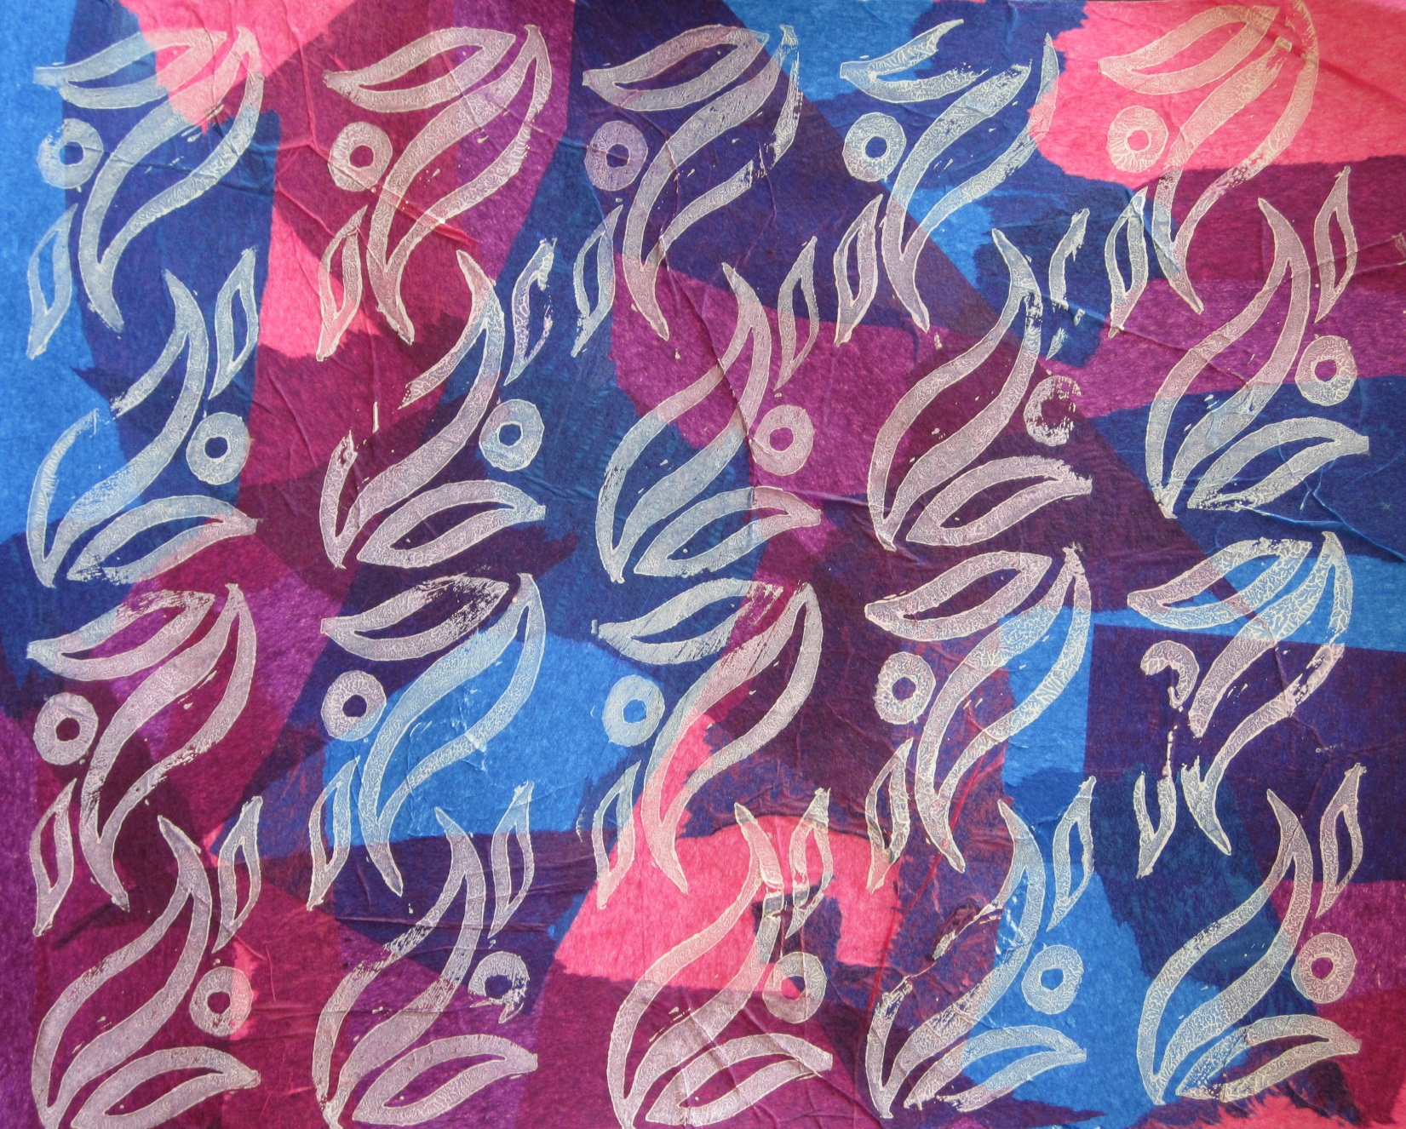

A. Where Art Classroom

B. Grade/Student Level 7th Grade

C. Class/Date/Times Two 50 minute periods

D. Room Description Art Room

II. CURRICULUM CONTENT:

Creative Expression and Communication
Students create artworks that demonstrate understanding of materials, processes, tools, media, techniques and available technology. They understand how to use art elements, principles and images to communicate their ideas in a variety of visual forms.

Grade Level Indicator:
3. Use a variety of sources to generate original ideas for art making.
- General Description

Students will use Speedball lino cutters to cut a motif in soft-cut linoleum. They will then print this motif in a pattern over a tissue paper collage.

- Cognitive Goals: (Bloom)

- Understand the art principle of pattern
- Understand the art element of positive and negative space
- Understand the fundamentals of relief printing

- Affective Goals: (Krathwohl)

- Follows directions well
  - Cooperates with teacher’s instructions
  - Asks questions when appropriate
  - Completes task as instructed
- Works independently
  - Able to complete task without seeking excessive assistance
  - Does not disrupt classmates with excessive conversation
- Works cooperatively
  - Shares materials when appropriate
  - Shares workspace when appropriate

- Psycho/Motor Skill Goals (Simpson)

- Cuts safely and accurately using linoleum cutting tools
- Prints a consistent, even pattern
  - Uses correct amount of ink
  - Lines stamp up in a gridded pattern
- Collages tissue uniformly

- Vocabulary: defined

Positive Space: The “image area” of a design. In a rubber stamp, the part that is printed after the rest is cut away.

Negative Space: The “non-image area” of a design. In a rubber stamp, the part that is cut away.

Pattern: Any design repeated regularly.

Motif: A simple design element meant to be repeated.

Relief Printing: A type of printmaking that involves rolling ink over a raised surface.

Brayer: A rubber roller with a handle, used for spreading ink in printmaking.

- Materials/Tools: quantity and quality specified

Numbers are specified per class of 20

- 20 Speedball lino tool sets
- 20 2” x 2” squares of soft-cut linoleum
- 20 sheets white sulfite paper, 12” x 18”
- 2 packages assorted tissue paper
- white glue
- 20 foam brushes
- 2 tubes black speedball water-based block printing ink
- 20 block stops
- 20 sharpie markers
- 20 number 2 pencils
- 40 sheets white printer paper (for sketching)

- Teacher Resources
- teacher exemplar

- Bibliography
  - www.odc.state.oh.us/curriculum-assessment/ci/
  - www. arteducators.org
  - www.oaea.org

III. TEACHING STRATEGIES
- Motivation: (Artistic, Intellectual, Imaginative, Kinesthetic) describe

Students will enjoy the satisfaction of getting to print their motif again and again.

- Methodology/Procedures (Hunter)

- T prep
  - Set out block stops, lino cutters, lino blocks, sharpies
  - Set out tissue paper, mat board/cardstock
- T demos lino cutting procedure
  - T sets up block stop, lino cutter, and piece of linoleum
  - T asks S for motif to cut
    - T defines motif verbally for S, provides examples
    - S provide motif
  - T sketches motif, transfers sketch to lino block with graphite transfer
  - T traces over graphite transfer with sharpie
  - T attaches v-gouge to speedball lino tool, outlines shape
    - T places block into block stop
    - T holds tool under palm of hand and cuts away from self at a shallow angle
  - T attaches u gouge and clears remainder of outside area
  - T reattaches v gouge and clears any interior spaces
    - Provides terms negative and positive space
- S cut blocks as demoed by T
  - Each S picks own motif, T assists with drawing motifs
  - S may use computers if needed
- S collage tissue paper onto card stock/mat board
  - S write name and class on back of mat board
  - S cut squares of various tissue papers
  - S dip foam brushes into a thinned water/glue mixture and spread this mixture in a thin layer on mat board
  - S Layer pre-cut squares smoothly over wet glue
  - S let dry

*******************DAY TWO*******************

- T demos lino block printing
  - T sets up slab, brayer, paper, ink, and stamp
  - T squeezes small line of black ink onto one end of slab
  - T rolls through line of ink with brayer, describes correct technique (like an airplane taking off, bacon sizzling, etc)
  - T rolls inked brayer over block
  - T lays block onto tissued board and presses firmly with heel of hand
  - T repeats in gridded pattern
- S print lino blocks as demoed by T
- S clean block by “ghosting” onto newsprint
- S clean rollers and slabs with warm water

