NAME Dina Hoeynck COURSE INSTRUCTOR

**I. PROJECT TITLE:**  Positive and Negative Space Acrylic Gel Transfers

A. Where High School

B. Grade/Student Level 11th Grade

C. Class/Date/Times 3-4 class periods; 50 minutes per period

D. Room Description Art Classroom and Computer Lab

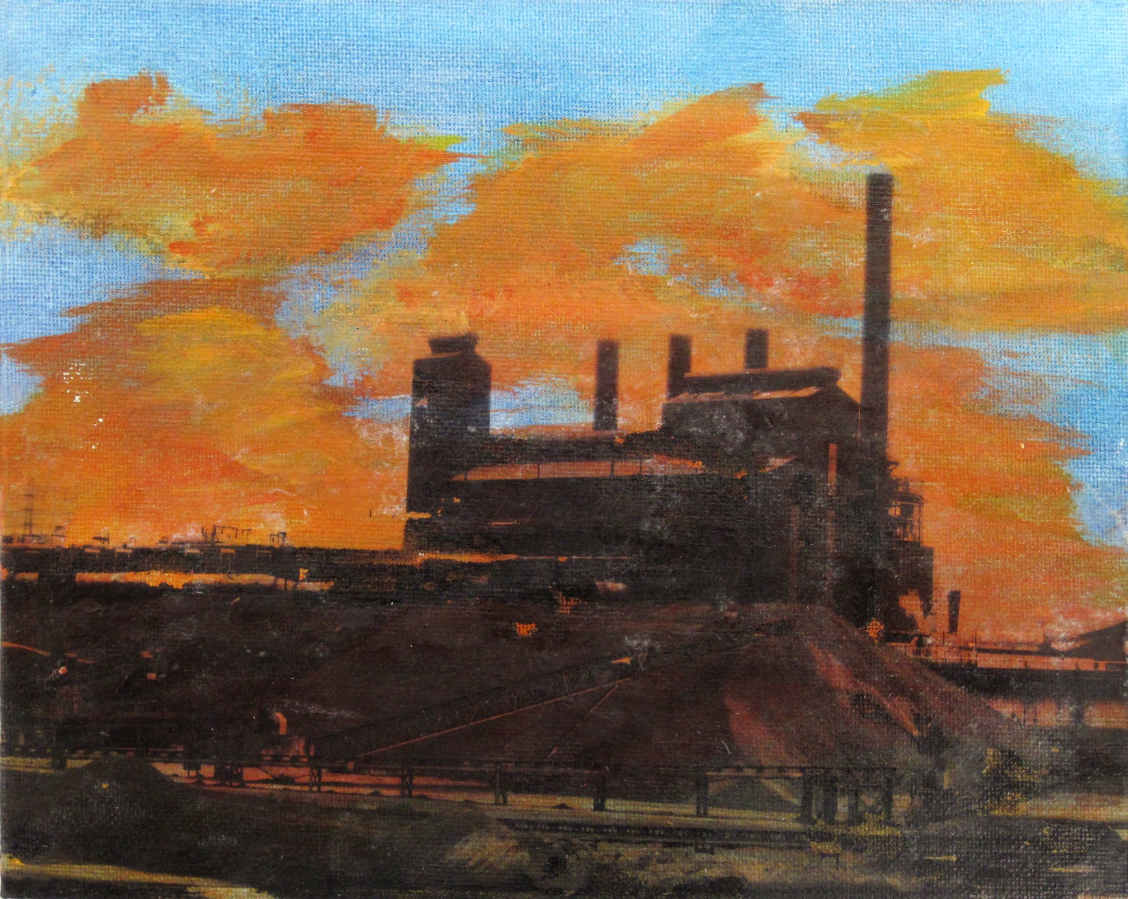

**II. CURRICULUM CONTENT:** **Art Studio**, Art History, Art Appreciation, Art Criticism

**Content Standard: Creative Expression and Communication**

Students create artworks that demonstrate understanding of materials, processes, tools, media, techniques and available technology. They understand how to use art elements, principles and images to communicate their ideas in a variety of visual forms.

**Grade Level Indicators:**

**10th grade:**

Create original artworks in at least two three-dimensional media and several two-dimensional media that show the development of a personal style.

**11th grade:**

Create original works of art that demonstrate increased complexity and skill and use a variety of two-dimensional and three-dimensional media.

1. **General Description**

Students will select original photographs based on their use of negative space. They will then use Adobe Photoshop to reverse, desaturate, and increase the contrast of the most effective photo. Next, they will paint an 8” x 10” canvas board to whatever color they would like in their negative space. Once this is dry, they will transfer the image to the canvas board using acrylic gel medium.

1. **Cognitive Goals: (Bloom)**
2. Knows how to use Photoshop for basic image manipulation
   1. Can crop and resize an image in Photoshop
   2. Can reflect an image horizontally in Photoshop
   3. Can desaturate an image in Photoshop
   4. Can adjust exposure of an image in Photoshop using curves
3. Understands Space
   1. Creates positive and negative space in composition
4. Understands contrast
   1. Creates contrast between foreground (dark black and white image) and background (light colored acrylic paint)
5. **Affective Goals: (Krathwohl)**
6. Values their own artistic efforts
   1. Demonstrates pride in his or her own work
   2. Works carefully and thoughtfully to produce the best work they can
7. Shows consideration for others while working.
   1. Shares materials with classmates
   2. Shares space with classmates
8. **Psycho/Motor Skill Goals (Simpson)**
9. Applies acrylic paint evenly
   1. Uses brush to blend acrylic paint
   2. Ensures no lumps of paint dry on canvas board
10. Transfers image using acrylic gel medium
    1. Applies gel medium in even, thin layer over back of image and canvas board
    2. Adheres image to board using baren
    3. Allows to dry
    4. Removes paper by wetting it and rubbing gently under fingers
11. **Vocabulary: defined**

**Value:** An element of art, *value* refers to the lightness or darkness of a color.

**Space:** The distances or areas around, between or within components of a piece.

**Positive Space:** The “image area” of a work.

**Negative Space:** The “non-image area” of a work

**Contrast:** The degree of difference between two art elements.

**Desaturate:** A Photoshop function that removes all color from an image.

**Curves:** A Photoshop tool that allows for subtle adjustments in value.

**Acrylic:** Plastic-based paint.

1. **Materials/Tools: quantity and quality specified**

* Digital photographs, original—3 per student
* Computer lab
* Laser printer
* Canvas board, 8” x 10”—1 per student
* Acrylic paint set
* Acrylic paint brushes
* ½ gallon acrylic gel medium
* Paper palettes

**III. TEACHING STRATEGIES**

1. **Motivation**: (**Artistic**, Intellectual, Imaginative, Kinesthetic) describe

Students will be interested in using a new process to make a visually exciting finished product.

1. **Methodology/Procedures (Hunter)**
2. T intro project
   1. T gives powerpoint slideshow of examples of positive and negative space in photography
      1. T discusses compositional strategies, rule of thirds
3. T assigns S to take or find 3 original photographs with strong positive and negative space relationships
4. T distributes canvas boards
5. S paint background of canvas board with acrylic paint
   1. S use palette knives to put desired colors onto paper palette
   2. S share palettes, 1 palette/4 students
   3. S tape palette to table
   4. S use brush to cover back of canvas with paint
      1. S may use paper towel to rub paint evenly across canvas
6. Clean-up
   1. S set paintings to dry
   2. S fold palettes in half and discard.

**\*\*\*\*\*\*\*\*\*\*\*\*\*\*\*\*\*\*\*DAY TWO\*\*\*\*\*\*\*\*\*\*\*\*\*\*\*\*\*\*\***

**Note: class meets in computer lab today**

1. S open up 3 images in Photoshop, perform following procedure on their favorite first. Other images function as backup in case favorite image does not work well (e.g. background too dark, etc).
2. T locksteps S through the following steps
   1. Image🡪 Image Size🡪8” x 10” x 300 dpi
   2. Image🡪Image rotation🡪 Flip canvas horizontal
   3. Image🡪adjustments🡪desaturate
   4. Image🡪adjustments🡪 curves
      1. Set black point with black eyedropper
      2. Set white point with white eyedropper
      3. Increase or decrease overall brightness by clicking and dragging curve
   5. File🡪save as🡪gel transfer image.jpg
   6. File🡪print
3. S and T return to room and apply images to canvas boards
   1. S apply thin layer of acrylic gel medium to board using card spreader
   2. S apply thin layer of acrylic gel medium to image using card spreader and/or fingers
   3. S lay image onto board
   4. S rub back of image with baren to ensure full adhesion
   5. S put boards away and let dry

**\*\*\*\*\*\*\*\*\*\*\*\*\*\*\*\*\*\*\*DAY THREE\*\*\*\*\*\*\*\*\*\*\*\*\*\*\*\*\*\*\***

1. S remove paper from transferred image
   1. S share cups of water in small groups
   2. S wet fingers and rub the back of the paper gently until it pills up and comes away from canvas board
   3. S continue until all paper is gone, leaving only image
2. S seal images with more gel medium (optional)
   1. This step may help hide some fuzzy paper fibers, if any remain.

**IV. ASSESSMENT/EVALUATION:** critical analysis of observed results



**V. COMMENDATIONS AND RECOMMENDATIONS FOR FUTURE LESSONS**

* Instead of curves, students could use layer adjustment🡪threshold to create high contrast, pure black and white images
* Ensure students cover tables with newspaper before using acrylic paints
* Inform students that acrylic paint will permanently stain clothing before distributing
* Lesson plan could be extended to allow students to use an image from their parents photo collections which could be scanned and modified in Photoshop (mini-lesson in found imagery)