**Lesson Plan/Format**

NAME Dina Hoeynck COURSE INSTRUCTOR

**I. PROJECT TITLE:**  Bonfire Landscape

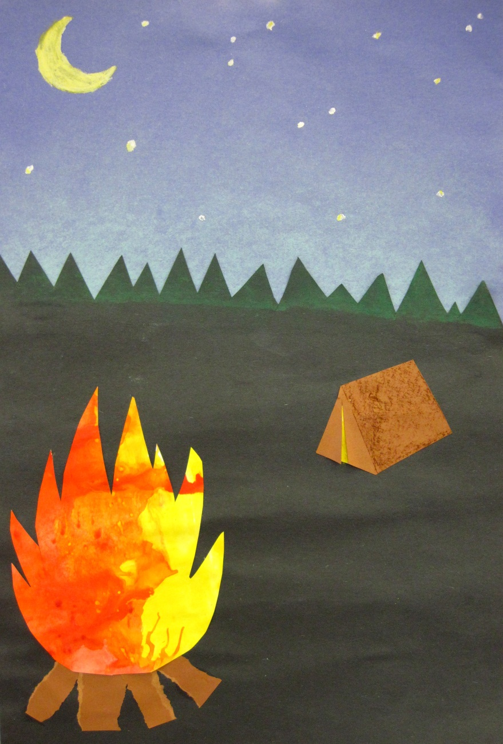

A. Where Art Classroom

B. Grade/Student Level 1st/2nd Grade

C. Class/Date/Times Two 50 minute periods

D. Room Description

**II. CURRICULUM CONTENT:**

**Creative Expression and Communication**

Students create artworks that demonstrate understanding of materials, processes, tools, media, techniques and available technology. They understand how to use art elements, principles and images to communicate their ideas in a variety of visual forms.

**1st Grade Level Indicators:**

1. Demonstrate beginning skill in the use of art materials and tools.
2. Explore and use a range of subject matter (e.g., people, places, animals and nature) to create original works of art .

**2nd Grade Level Indicators:**

1. Demonstrate increasing skill in the use of art tools and materials.
2. Create artworks based on observation of familiar objects and scenes in the environment.
3. **General Description**

First, students will blow red, yellow, and orange tempera paint out of straws onto white paper to make “fires,” which will be set aside to dry. Then, they will create nighttime landscapes on dark blue paper with a tree-line, moon, and stars, using cut paper, chalk pastels, and oil pastels. Finally, they will cut out and glue down the fires and tear brown construction paper as sticks.

1. **Cognitive Goals: (Bloom)**
2. Knows the warm colors
   1. Names the three warm colors out loud during class
   2. Paints the three warm colors in the bonfire
3. Understands space
   1. Creates space in the composition by making the bonfire bigger than the trees
   2. Understands terms “foreground” and “background”
4. Understands emphasis
   1. Creates emphasis on the bonfire by making it brighter than the rest of the composition
5. **Affective Goals: (Krathwohl)**
6. Follows directions well
   1. Cooperates with teacher’s instructions quickly
   2. Asks questions when necessary
   3. Completes task as instructed
7. Works independently
   1. Able to complete task without seeking excessive assistance
   2. Does not disrupt classmates with chatter or play
8. Works cooperatively
   1. Shares materials nicely
   2. Shares space nicely
9. **Psycho/Motor Skill Goals (Simpson)**
10. Uses a straw to apply tempera paints
    1. Dips straw halfway into thinned tempera paint, then holds finger over top of straw to create suction and keep the paint from falling out.
    2. Releases straw over paper and blows paint across page to make fire-like patterns
11. Cuts bonfire out of paper
    1. Cuts around edges of bonfire so white paper isn’t showing
    2. Cuts in smooth, non-raggedy lines
12. Tears paper for bonfire sticks
    1. Tears slowly and steadily by pinching paper between fingers and pulling one hand forward and the other hand back.
13. Pastes bonfire and sticks onto paper
    1. Applies glue on backs of cut objects in a thin line around perimeter
14. **Vocabulary: defined**

**Landscape:** A picture of a place outdoors in nature.

**Warm Colors:** Red, yellow, and orange.

**Horizon:** The line where the ground meets the sky.

**Space:** Space is the sense of depth in a picture. Space can be created by making objects in the foreground bigger than objects in the background, by overlapping, or by making objects in the foreground more detailed or brighter than objects in the background.

**Emphasis:** A principle of design. Emphasis is when the artist creates a single focal point for a composition. This can be accomplished through contrast.

**Foreground:** Objects in the front of a landscape, closest to the viewer.

**Middle Ground:** Objects in the middle of a landscape, medium distance from the viewer.

**Background:** Objects in a landscape furthest from a viewer.

1. **Materials/Tools: quantity and quality specified**

**Note: materials listed for 80 students, 4 classes of 20**

* 16 oz bottle red tempera paint
* 16 oz bottle yellow tempera paint
* 16 oz bottle orange tempera paint
* 100 sheets blue construction paper, 18” x 24”
* 100 sheets black construction paper, 18” x 24”
* 100 sheets white sulfite paper, 18” x 24”
* 10 sheets brown construction paper, 18” x 24” (cut into 3” x 12” strips)
* 18 plastic cups (for colored paints)
* 250 disposable plastic straws
* 20 yellow oil pastels
* 20 white oil pastels
* 20 pale blue chalk pastels
* 20 pairs small student scissors
* 20 bottles Elmer’s white glue
* 20 #2 pencils

1. **Teacher Resources**

Teacher Exemplar

1. **Bibliography**
   1. [www.odc.state.oh.us/curriculum-assessment/ci/](http://www.odc.state.oh.us/curriculum-assessment/ci/)
   2. [www. arteducators.org](http://www.arteducators.org)
   3. [www.oaea.org](http://www.oaea.org)

**III. TEACHING STRATEGIES**

1. **Motivation:** (Artistic, Intellectual, Imaginative, **Kinesthetic**) describe

Students will blow through straws to spread paint on paper.

1. **Methodology/Procedures (Hunter)**
2. T prep:
   1. Mix 6 plastic cups (filled only 1/3 of the way) each of yellow, red, and orange tempera paint thinned to 50% with water. Set aside.
3. T introduces project, explains that they will be making landscape pictures with camp fires.
   1. T asks who knows what a landscape is.
      1. S answer
   2. T asks S who has been camping before
      1. S answer
   3. T describes how when you’re camping, everything is really dark except your fire, so you notice the fire more than anything.
      1. T defines this as emphasis.
   4. T asks what colors are in a fire, warm or cool?
      1. S answer “warm”
   5. T asks who can name the warm colors
      1. S answer red, yellow, orange
4. T demonstrates making fire with straws.
   1. T lays white paper on table and collects cups of paint and 3 straws
   2. T has S gather around table
   3. T says, “first, I’m going to put my name on the back of the paper!”
   4. T explains that S will suck the paint up into the straw part of the way, but not all the way, then use their tongue to close up the straw and hold the paint in.
   5. T asks S what would happen if they suck paint all the way up the straw
      1. S reply, ewww, yucky!!
   6. T demonstrates with red, sucking paint into straw then moving it over the page, letting it go, and blowing it to make flame-like patterns.
   7. T repeats with yellow and orange paints.
5. S make fire with straws.
   1. T distributes one set of paints for each table.
   2. T asks for two S helpers.
      1. One S distributes a piece of paper to each seat.
      2. One S distributes 3 straws to each seat.
   3. T reminds all S to put their names on the back before they start.
   4. S use straws to create fire as demonstrated previously by T.
   5. T instructs S to throw each straw in the garbage as they finish with it.
6. T cleans up a little by removing paint cups from tables.
7. T demos creating treeline on landscape.
   1. T lays out one piece each of blue and black paper, and chalk.
   2. T asks S to gather round.
   3. T asks S, “what do I do first?”
      1. “Put your name on the back of the paper!”
   4. T explains that the trees will be silhouetted by the sun setting.
   5. T says that horizon line should be more than halfway up the page so we have enough room for our fires.
   6. T cuts a zig-zag line at horizon, emphasizing that the triangles should be skinny so they look like pine trees.
   7. T lays black paper over blue and holds it up.
   8. T explains that it will look even better if the sky gets a little lighter toward the horizon, then lifts black paper and uses side of blue chalk to lighten the horizon by dragging firmly back and forth across the page.
   9. T blends chalk line upward with fingertips.
   10. T uses elmer’s glue to glue black paper in place
8. S create treelines.
   1. T asks for two S volunteers.
      1. One distributes blue paper, the other black.
   2. S repeat steps as demonstrated by T, with T calling out the steps for them as reminders.
      1. First, cut a treeline
      2. Second, lighten the sky at the horizon and blend.
      3. Third, paste down the black paper.
9. If time permits, S may begin to add stars and moon using white oil pastels. Yellow can be used over the white.
10. Clean-up according to standard assigned tasks.
11. Distribute exit cards asking S to list the warm colors.

***************DAY TWO***************

1. T tells S that last time, they made the background of their picture, and this time, they will may the middle ground and foreground.
   1. T defines background as the things furthest away.
   2. T defines foreground as things closest.
   3. T asks S, “If background is far away, and foreground is close, what do you think middle ground is?
      1. “In the middle!”
      2. Right!
   4. T tells S that their fire will be in the foreground, and they will make a tent for the middle ground.
2. T asks a student volunteer to distribute fires and backgrounds.
3. T demonstrates how to cut fire
   1. T cuts a big oval.
   2. T explains that it need to be bigger than the other things in the landscape so it will look like it’s closest.
   3. T says, “now I’m going to make it really look like a fire” and cuts flame-like spikes in the top of the oval.
   4. T sets fire aside.
   5. T tells S, if they have enough painted paper left, they may make a second, smaller flame as well.
4. S create fires as demonstrated by T, set aside.
5. T asks S to distribute brown construction paper.
6. T shows S how to make logs and tent out of brown paper.
   1. For logs, cut a 2” wide long strip, then tear that strip into finger-width sections.
      1. Put a thin line of glue on the back of each log and glue them below where the fire will go. Arrange them like an upside down fan, so their tops are touching but their bottoms are evenly spaced apart.
   2. For tent, T demonstrates drawing the tent on large paper at the front of the room and has S draw along in pencils on brown paper.
   3. T reminds S that tent should be smaller than fire, because it’s in the middle ground.
      1. T draws isosceles triangle and explains that this is the front of the tent
      2. T draws rectangle receding away and explains that this is the side of the tent.
7. S cut and glue logs as demonstrated.
8. S cut tents.
   1. T shows S how to make a small cut where the tent door would open, being careful not to cut all the way through.
   2. S repeat
   3. T shows S how to curl the paper up so it looks like the tent door is opening a little
   4. T tell S to take a little piece of white paper and color it with yellow oil pastel, then stick it behind the tent door to look like light coming from inside.
9. T has S glue down tents and fires.
   1. T reminds S that the tents should be halfway between the bottom of the page and the horizon, in the “middle ground”
   2. T reminds S that the fire should overlap the logs that they have already glued down.
   3. T reminds S not to use too much glue
10. S who have not already done so add stars and moon using white oil pastel, then yellow oil pastel.
11. Students clean up according to established procedures.
12. T distributes exit cards asking S to identify which object was in the foreground, middle ground, and background.

C. Discipline Model Description (Canter)

**IV. ASSESSMENT/EVALUATION:** critical analysis of observed results

**Observation Criteria:**

* Student is on-task and working
* Student does not distract others
* Student works carefully (e.g. does not spill paint on floor)

**Exit Card:**

Circle the warm colors:

RED BLUE

GREEN ORANGE

YELLOW PURPLE



**V. COMMENDATIONS AND RECOMMENDATIONS FOR FUTURE LESSONS**

* Create a few extra teacher exemplar fires for students who miss day one of project to use on day 2
* Create a handout that students could use to catch up if they fall behind due to absence or general slowness
* Allow for one or two more optional elements (e.g draw a person next to the fire, etc)